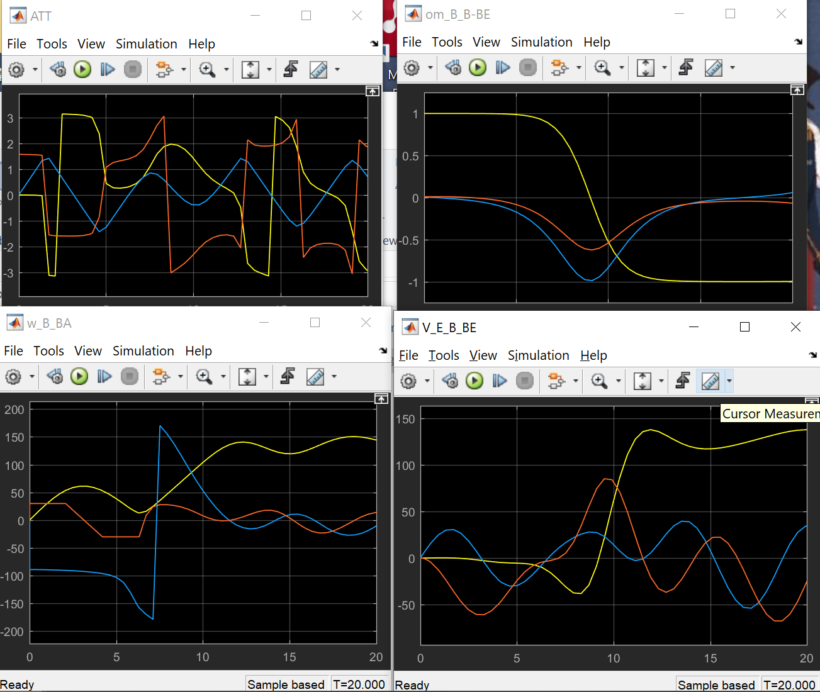

Simulink Blocks:

摘要：

这个研究报告的气动模型是基于ASW28的模型的数据和12个状态方程搭建的，从而实现模型控制系统设计与气动布局分析的研究目标

首先，系统框图搭建并根据ASW28的气动面布局与具体参数进行改良；then，

The system block diagram was built and improved according to the aerodynamic surface layout and specific parameters of ASW28

The aerodynamic model of this report is based on the data of ASW28 model and 12 equations of steady state. The research objectives is the design of model control system and the basic aerodynamic analysis

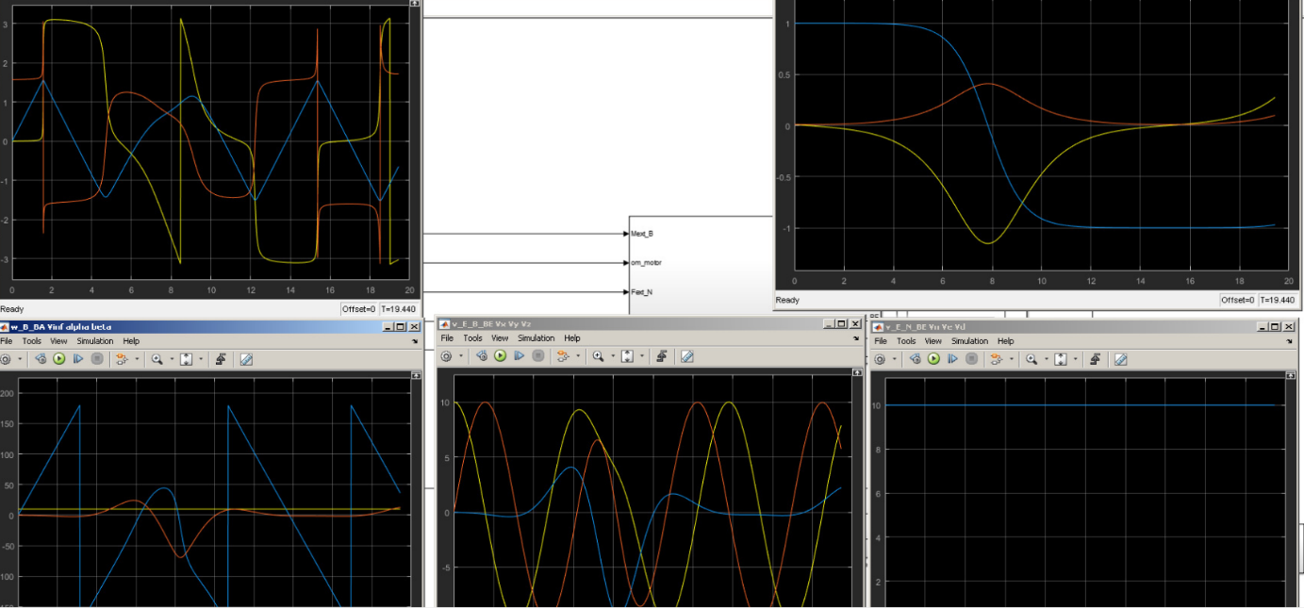

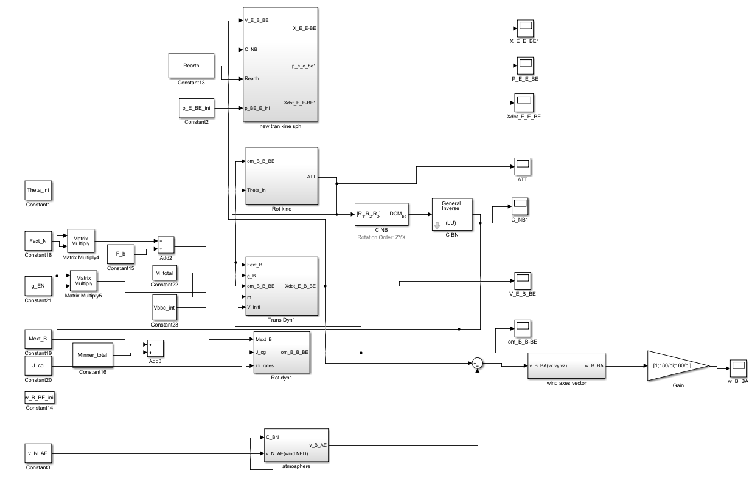

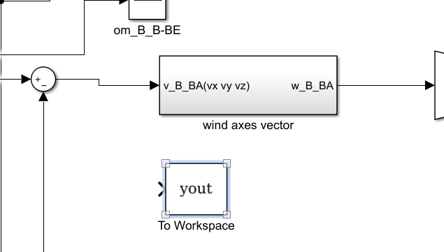

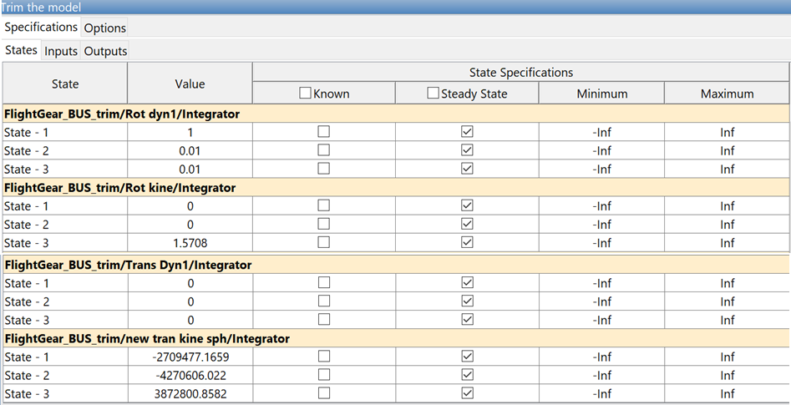

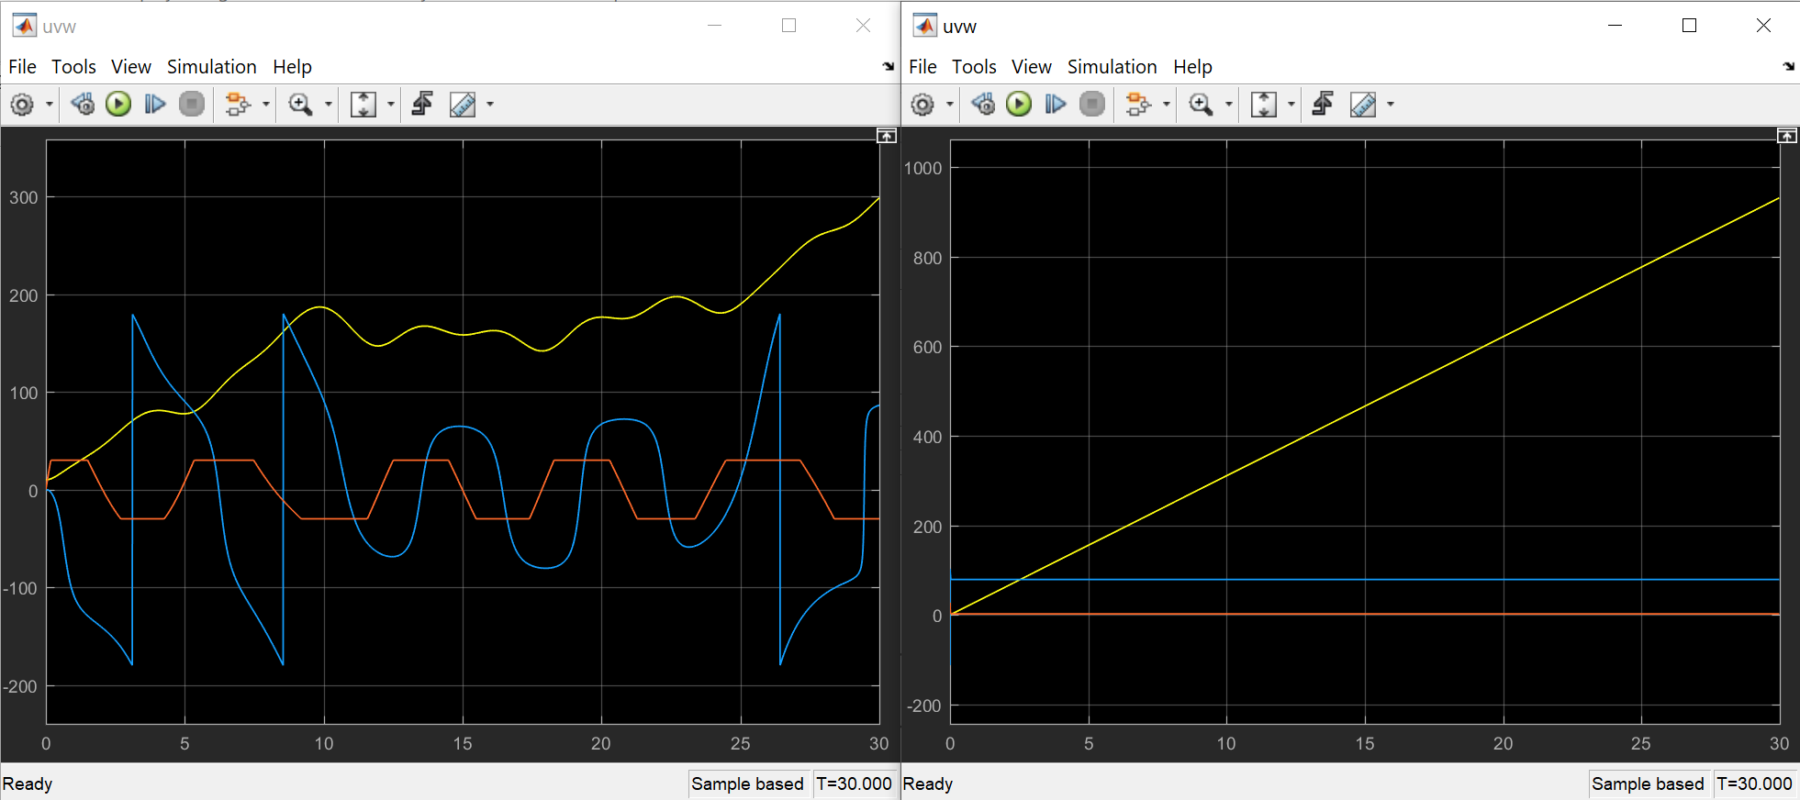

FlightGear:

Simulink version: v2016.3

1. 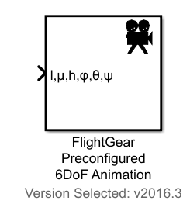

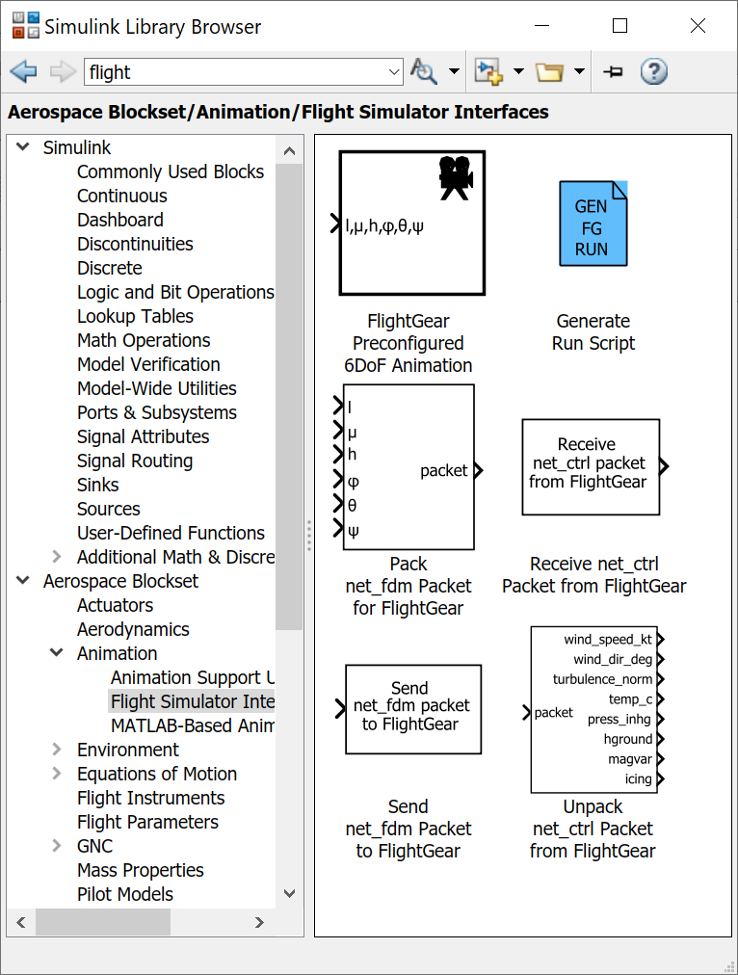

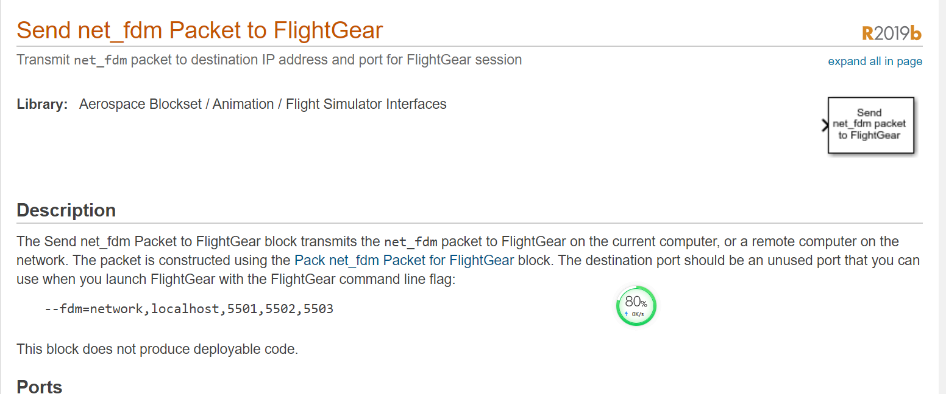

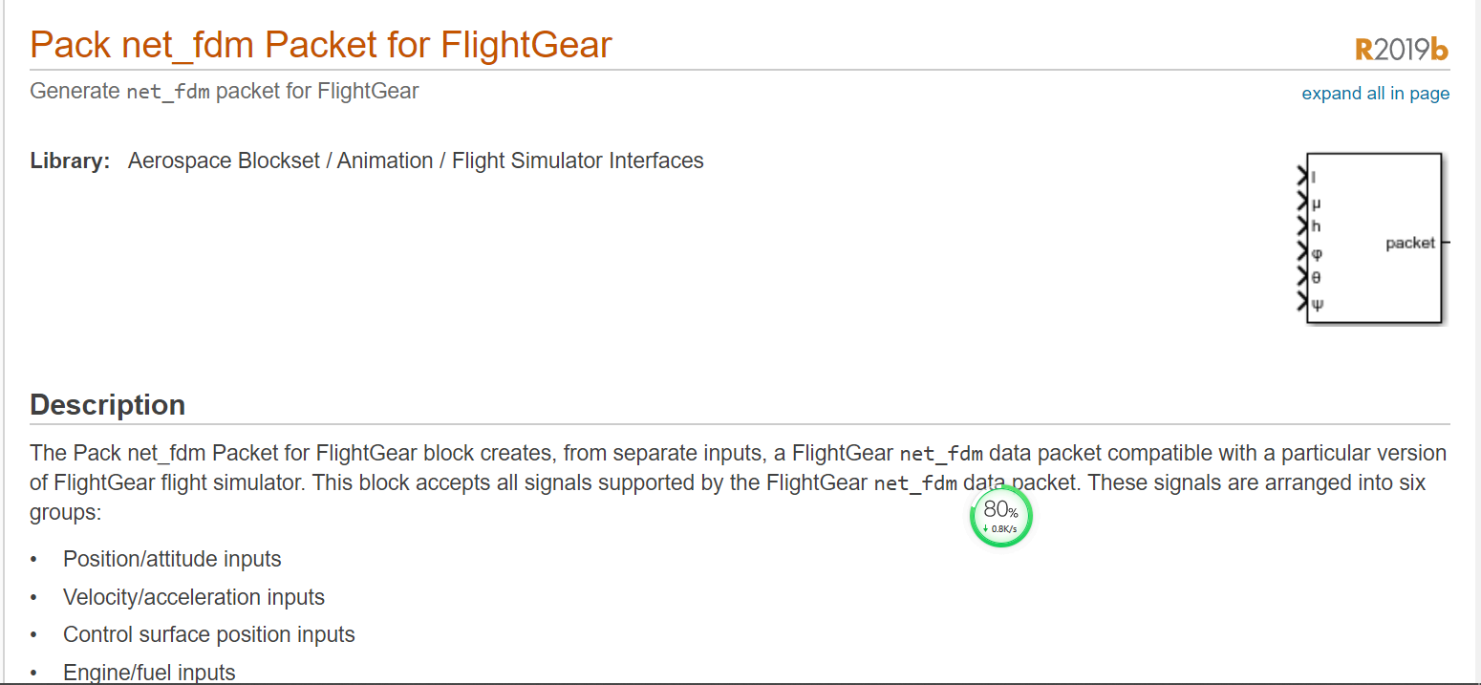

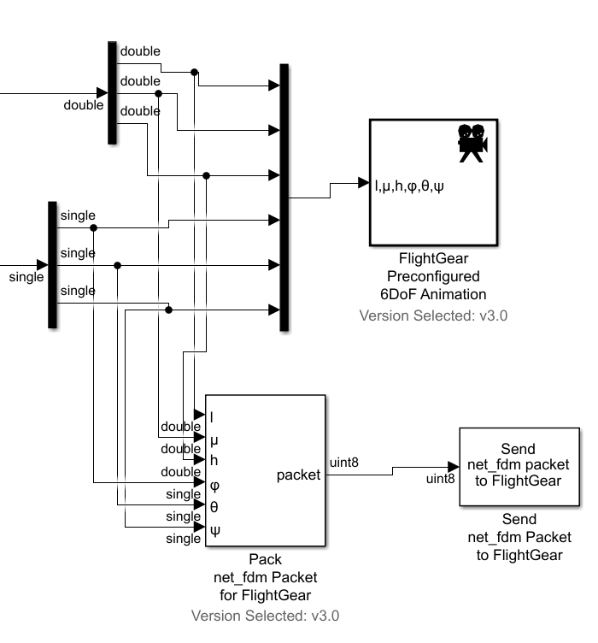

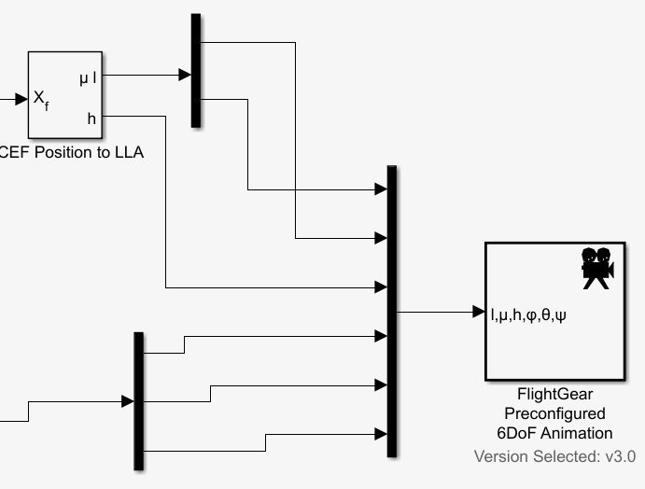

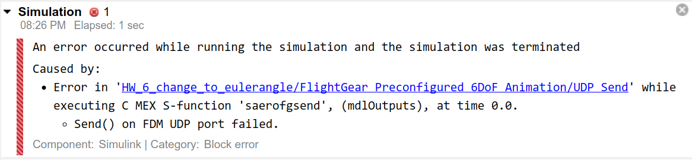

Windows PC's local IP address by running a command called "ipconfig" in a Command Prompt window.

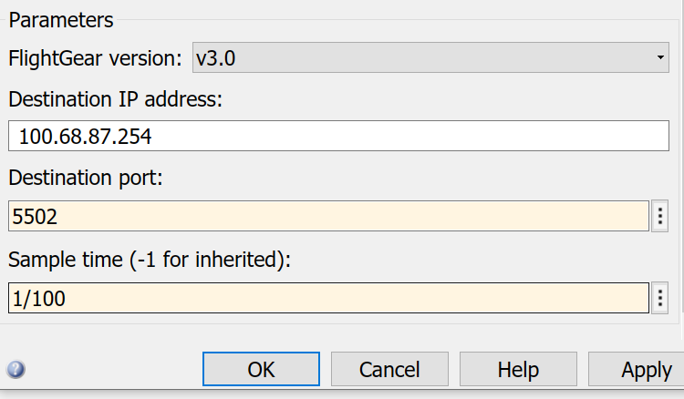

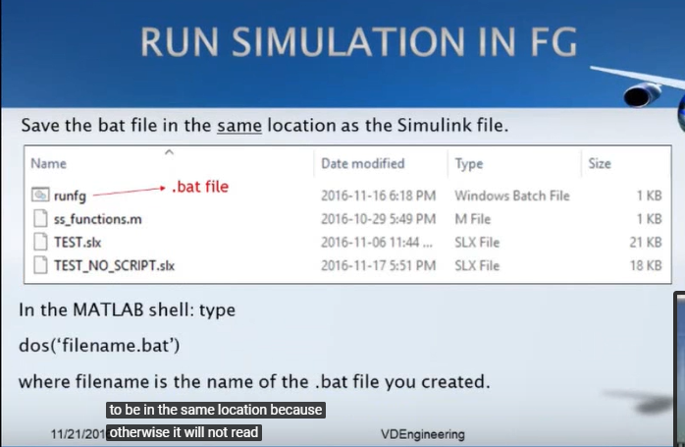

.bat

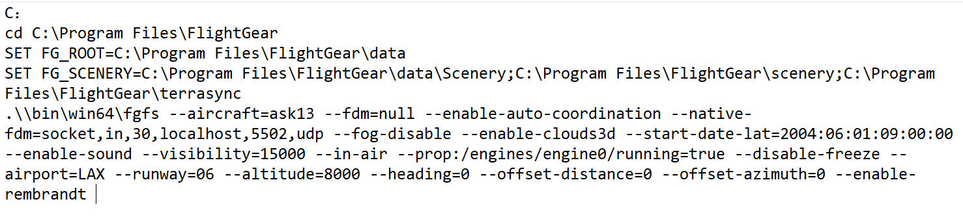

IMPORTANT:

Press V and H buttons can change the pilot view!

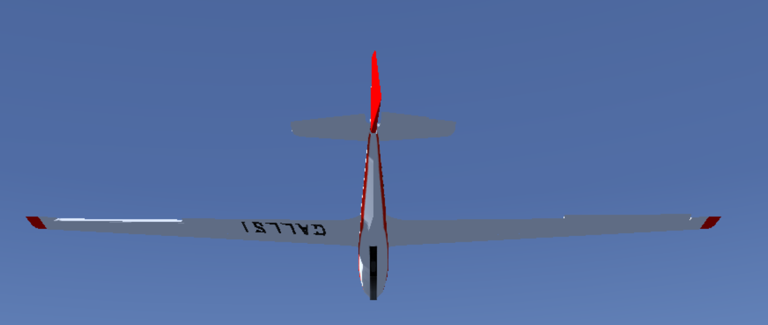

My ip address:

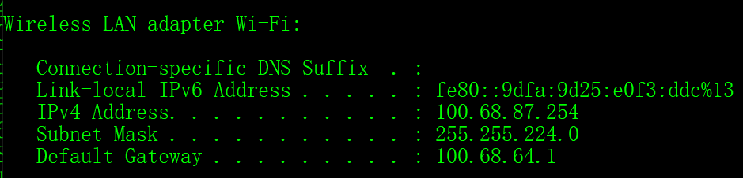

My active ports:

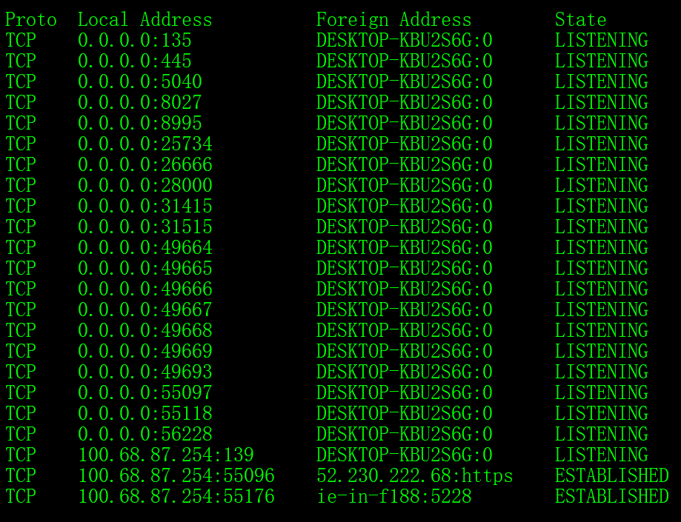

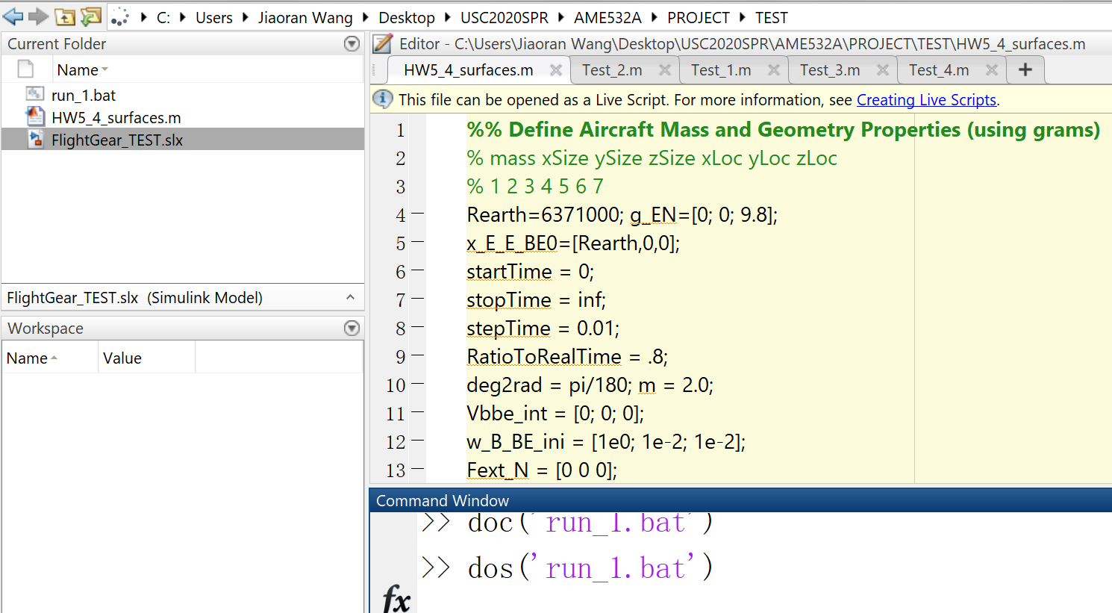

I found out if I run the .bat and .slx separately they may not communicating with each other. But if I run .bat in MATLAB then MATLAB may continually running then I could not run the .slx

Procedure:

1) open MATLAB cd(tempdir)

2) locate the TEST folder

3) run surface.m

4) open .slx

5) command dos(‘run_1’)

6) sim(‘FlightGear_TEST’) Then I couldn't run .slx anymore…

I looked into the note about setting up solution

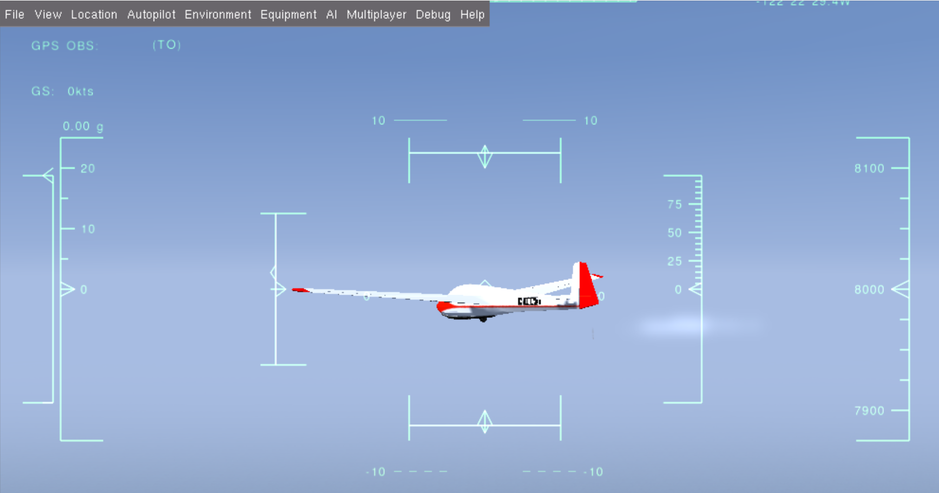

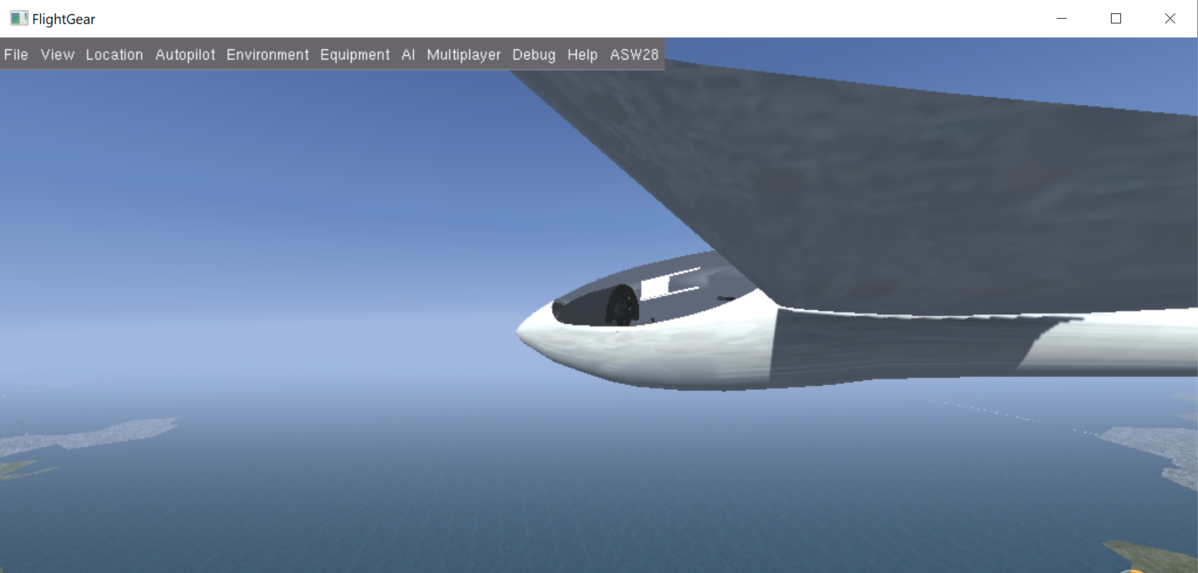

Animation Simulink

For this part I decided to start over to build a command block for simulation.

PID CONTROLLER

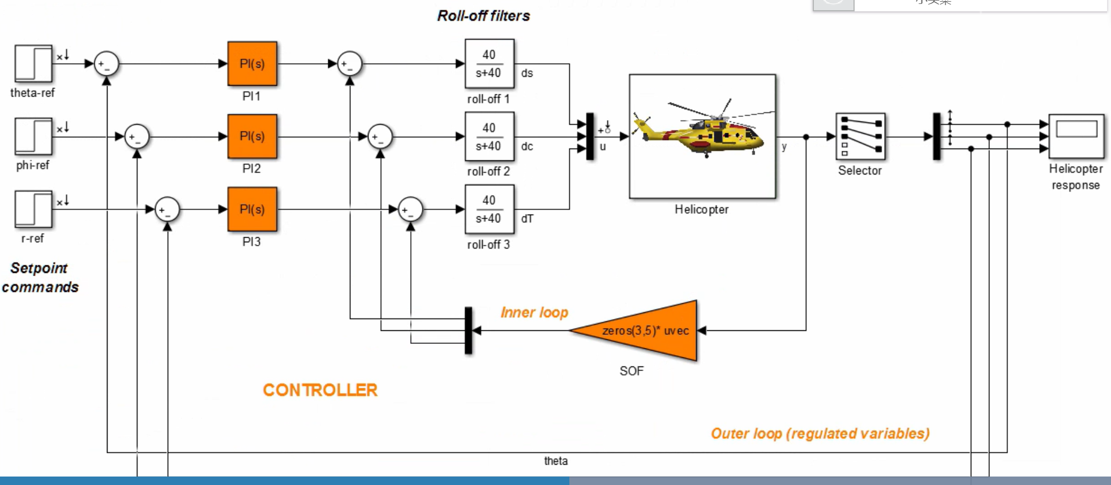

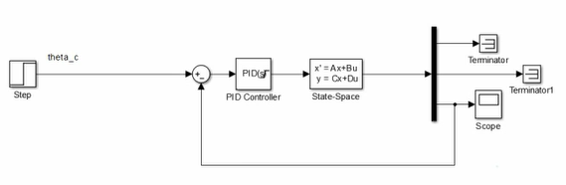

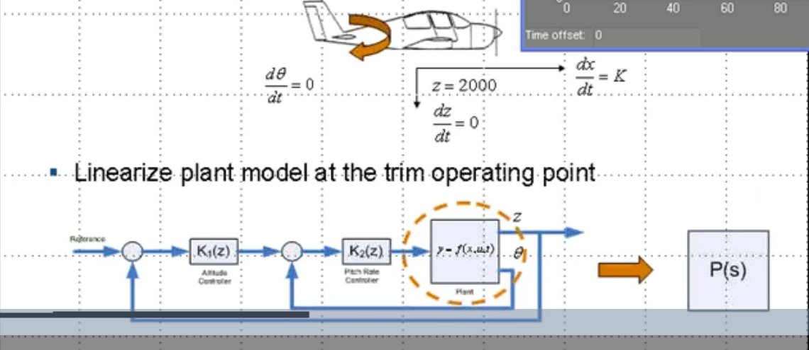

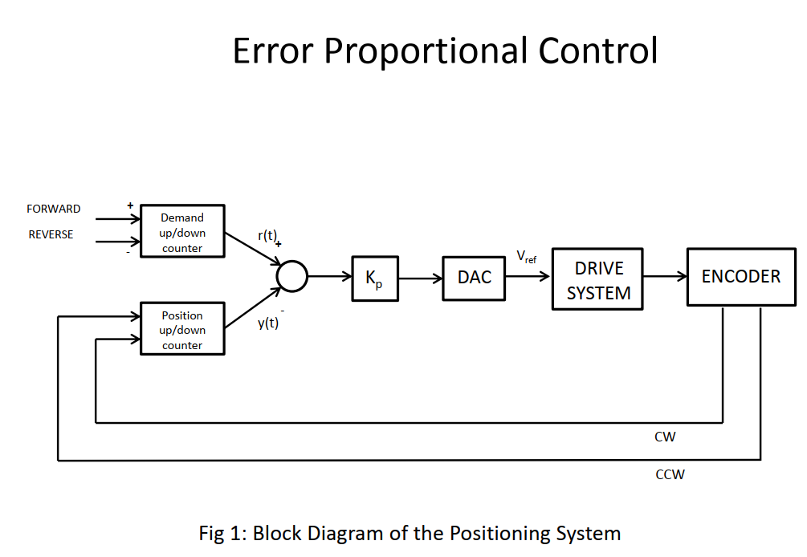

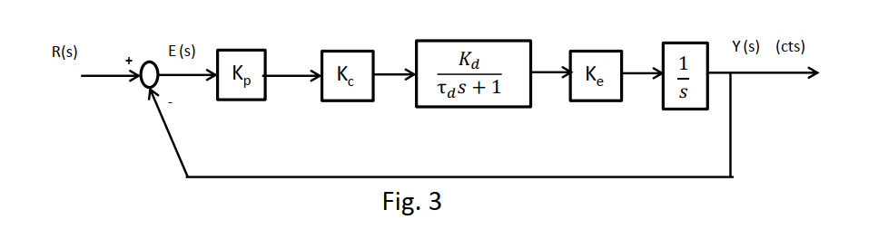

[ROLL ANGLE CONTROL]

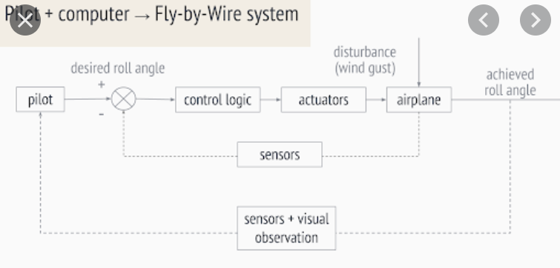

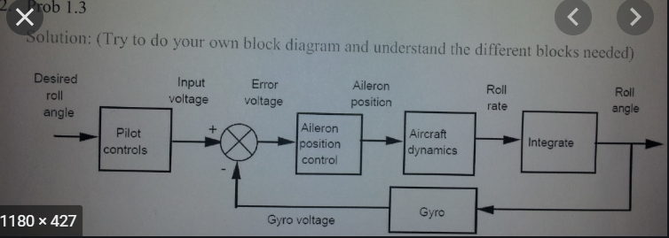

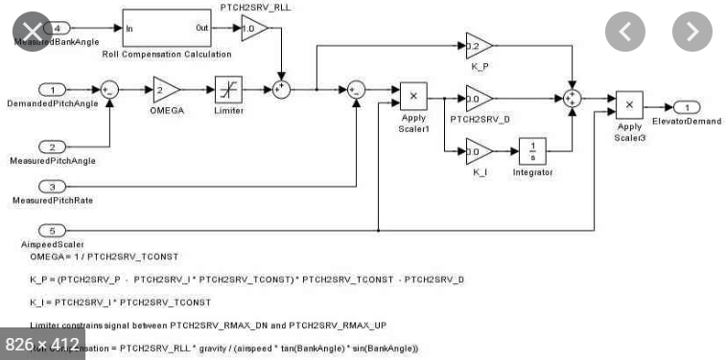

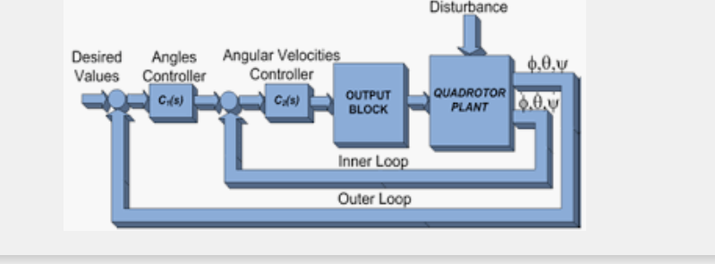

Design an angle (roll) control with inner loop and outer loop

For roll only:

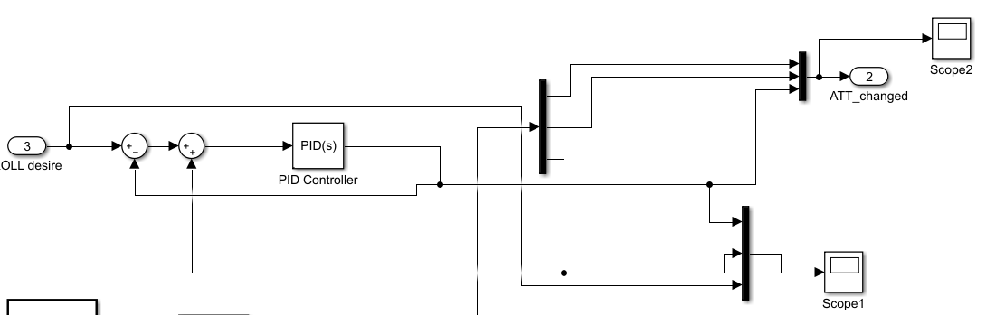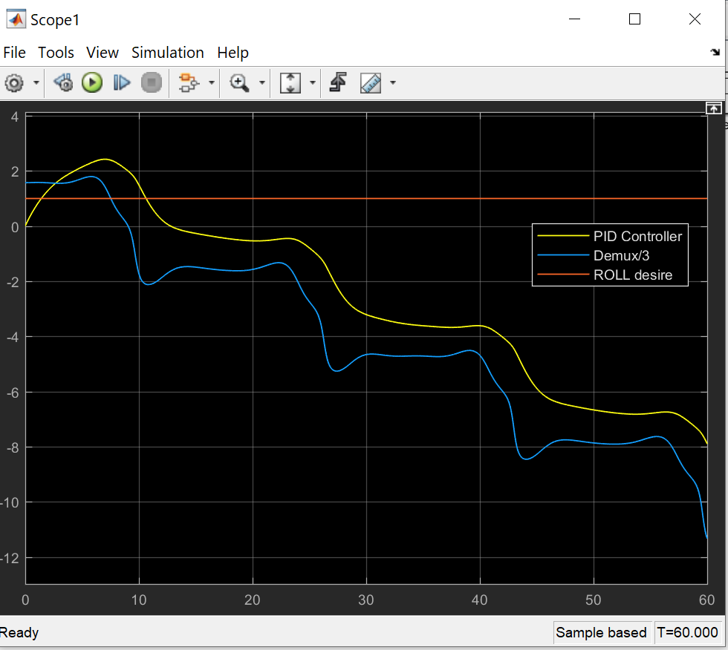

It’s okay before 50s but destabilize after 50s and vibration begains

Just a simgle PID controller in the loop

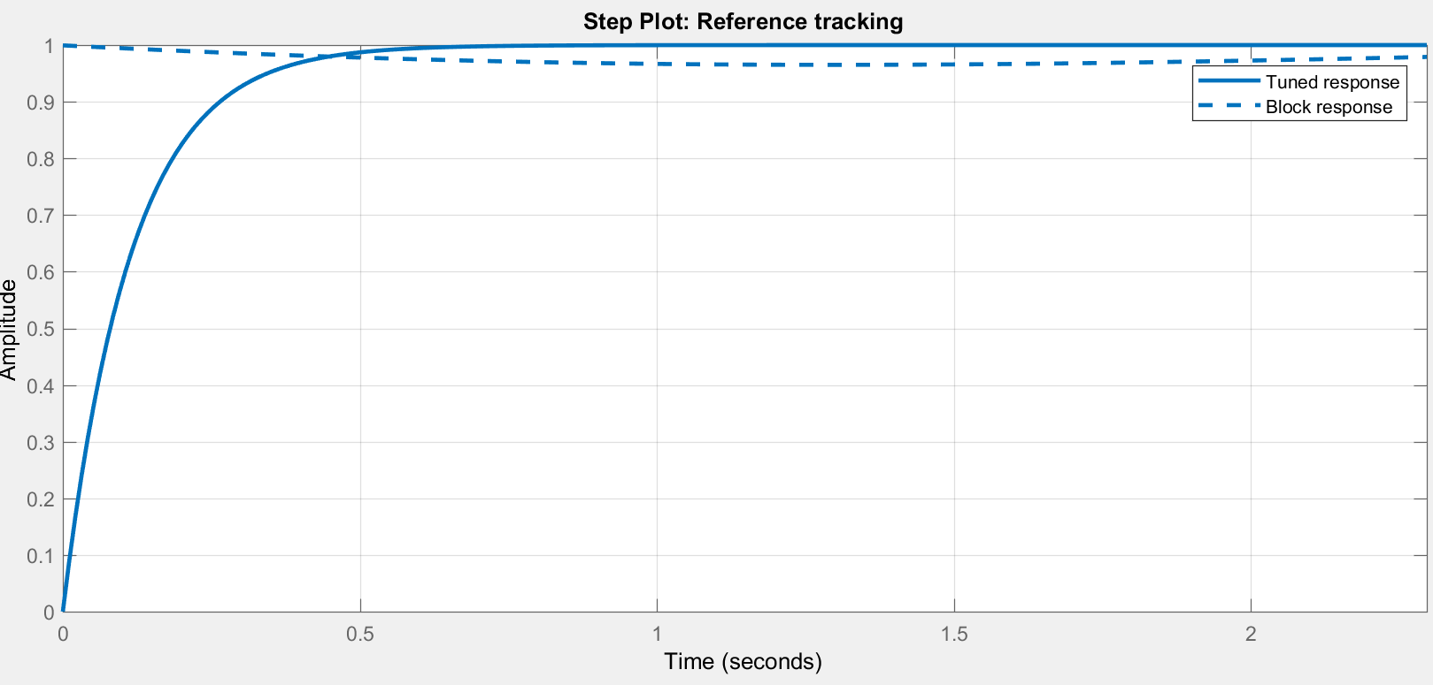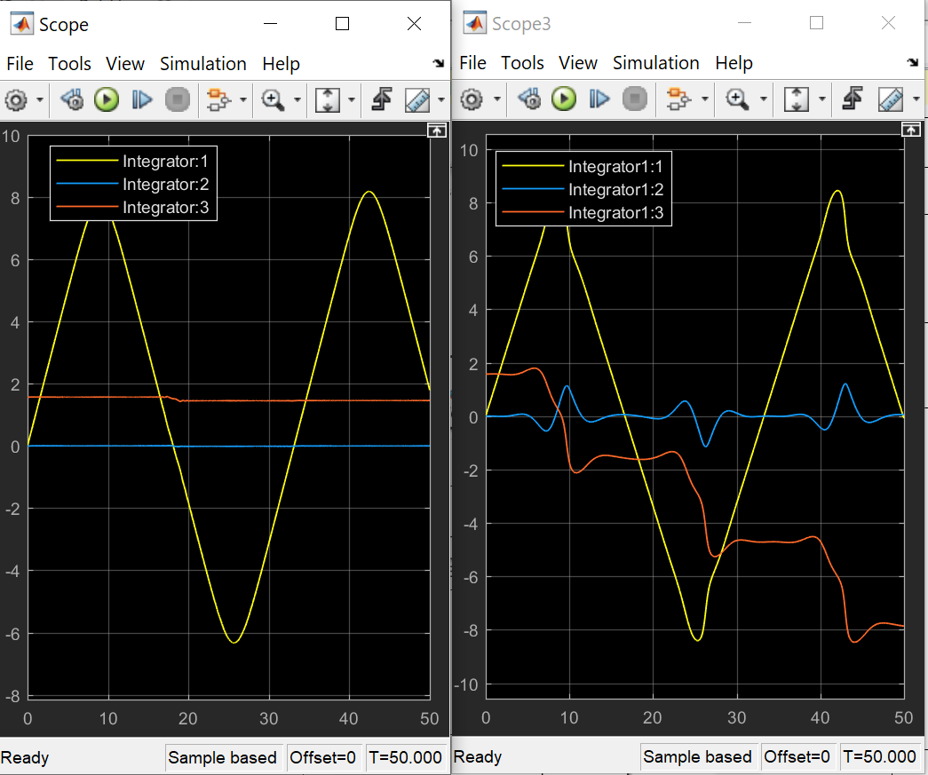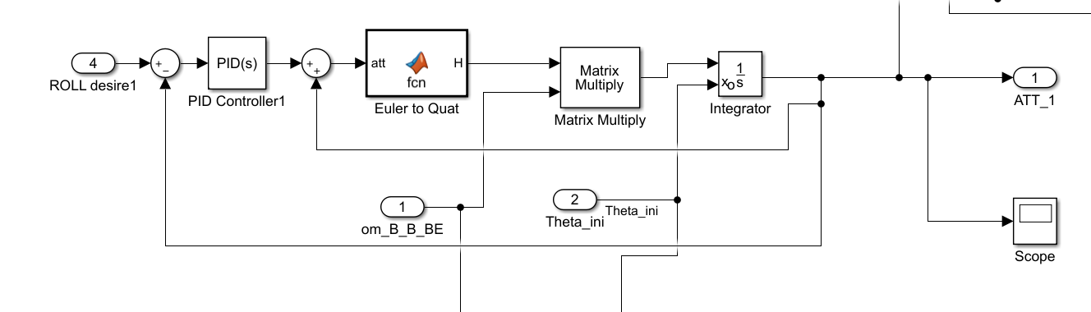

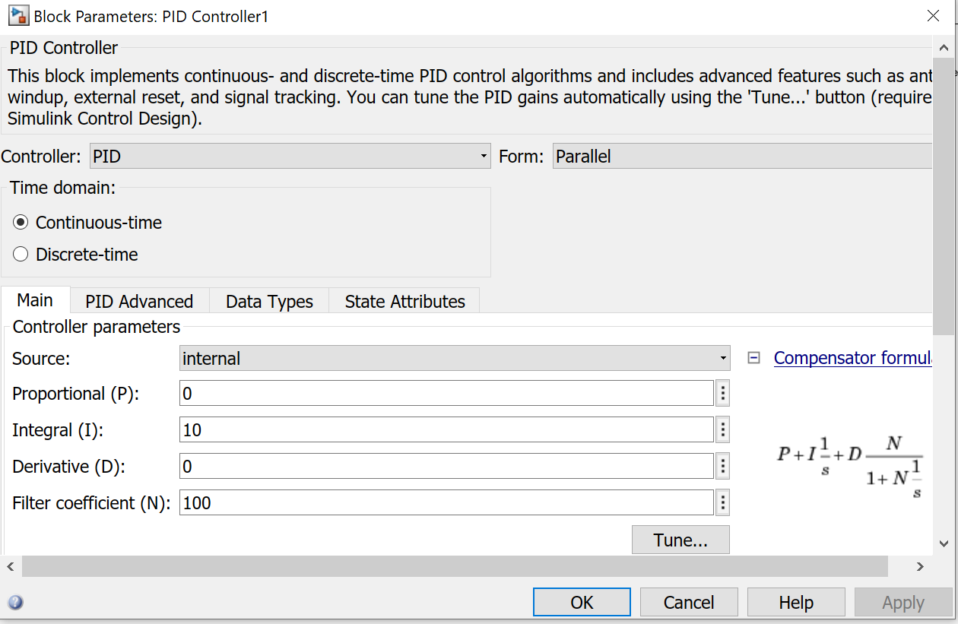

Adding PID controller to each yaw pitch and roll and tune them

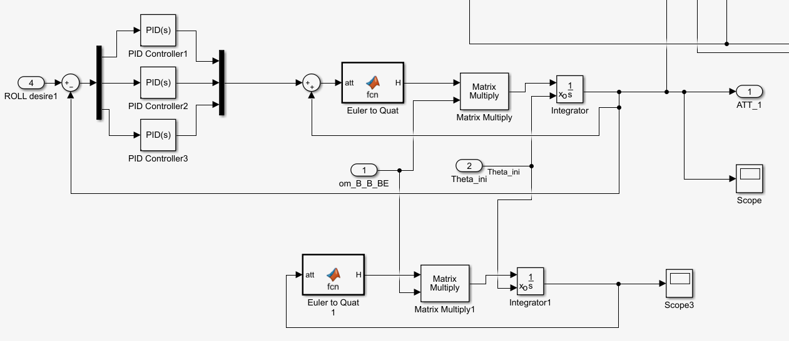

Roll:::

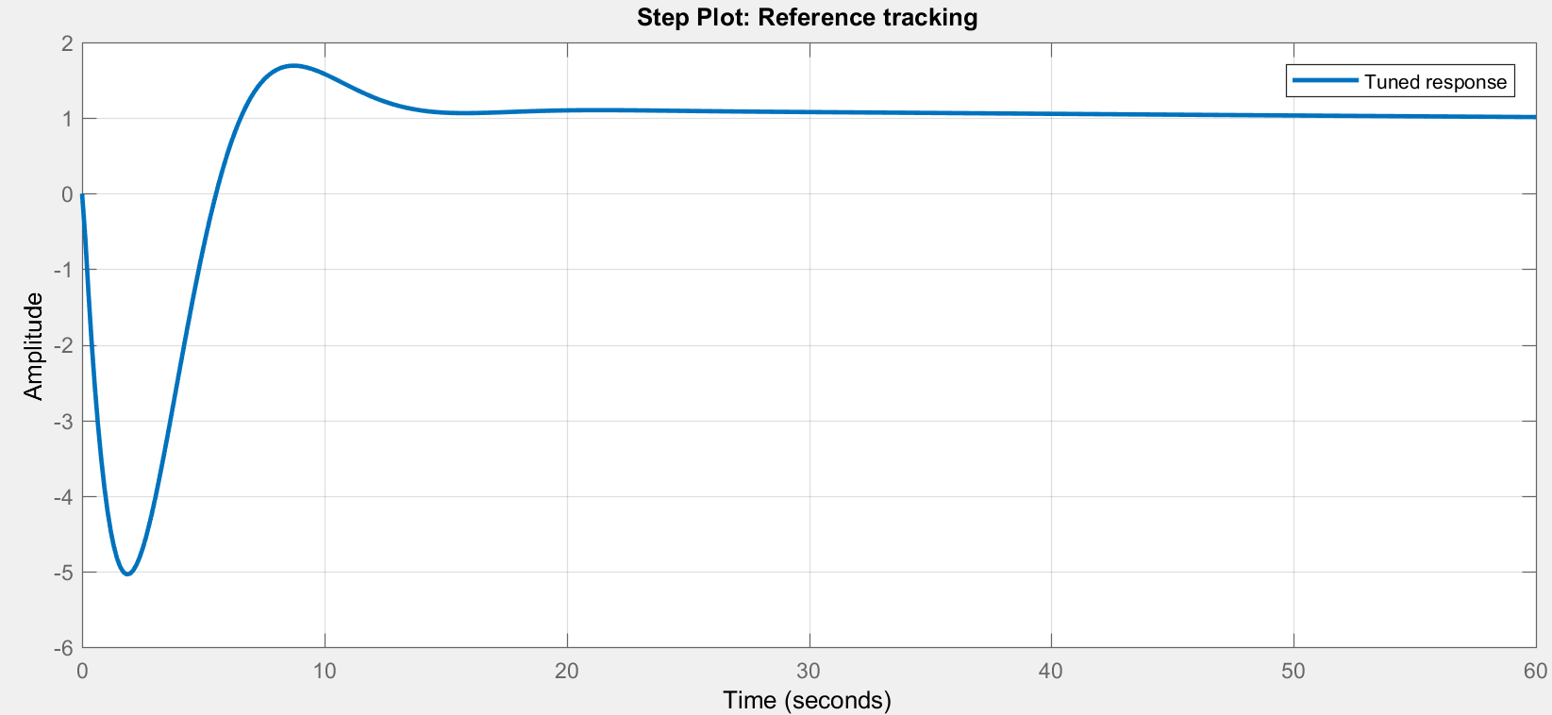

Yaw:::

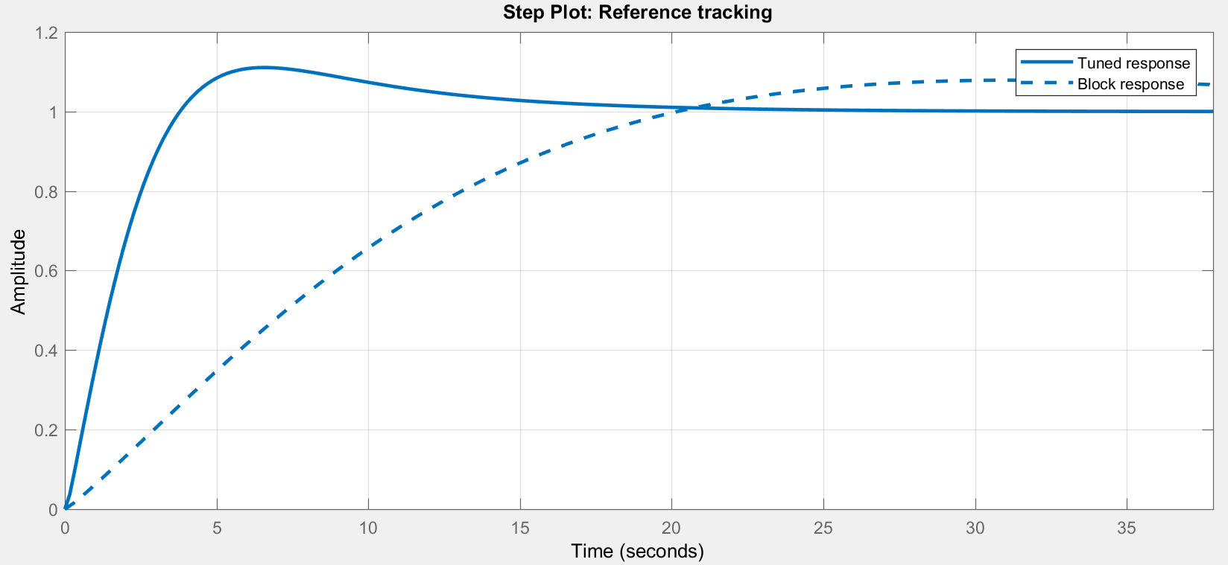

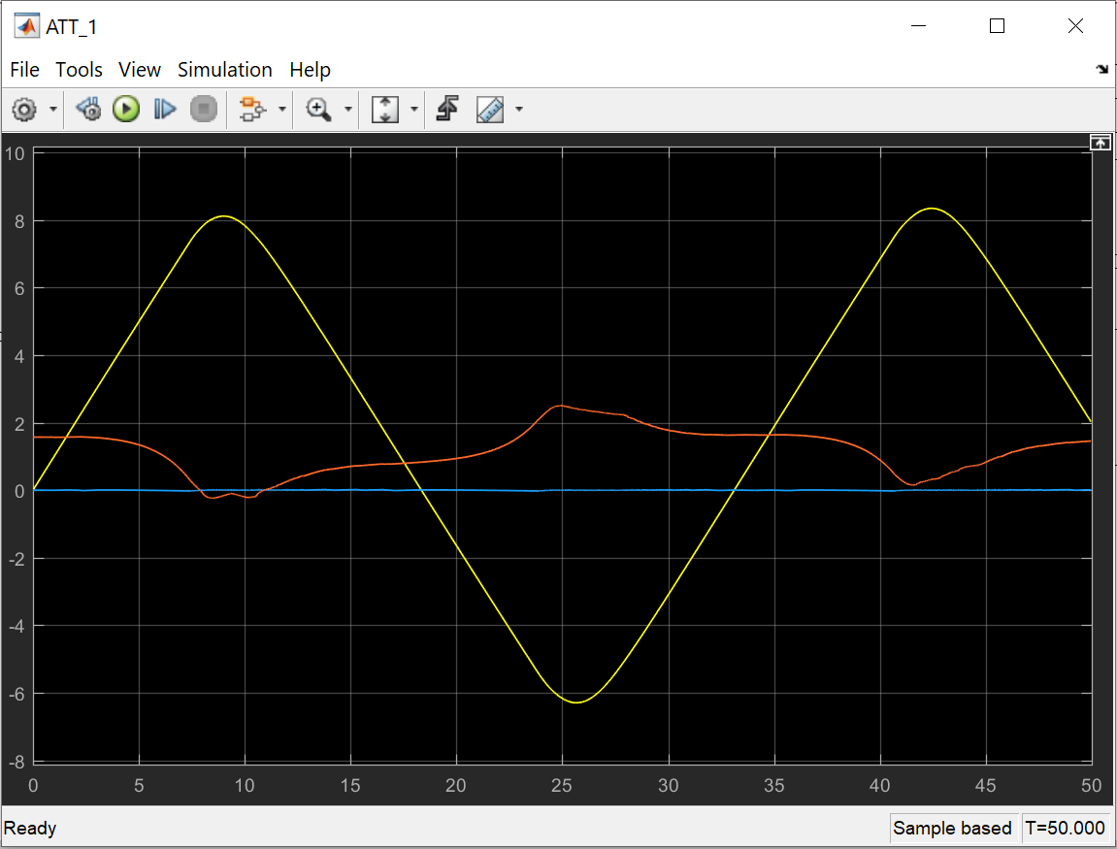

It’s not so great like using single PID controller, as they are coupled. Then as I don’t know how to decouple them, I would try just adding simple PID controller

Altitude control

Auto Pilot control:

[By using state function to trim the model!

Could use the autopilot for ideas]

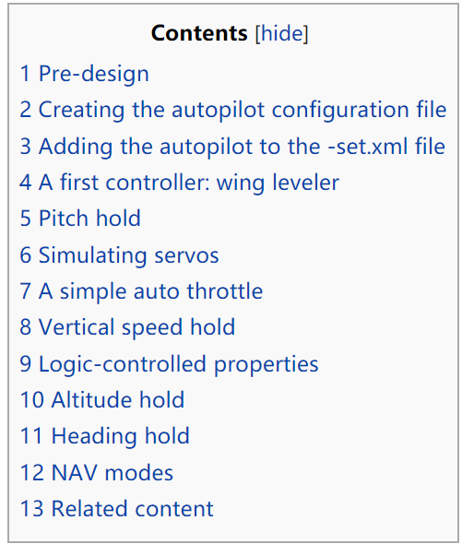

A first controller: wing leveler

Let's start with a simple wing leveler that keeps your bank angle at zero (or any arbitrary value later). This could be a PID controller with the input from your current roll and a reference of zero. Output should go to your aileron-cmd. Start with:

* **Kp:** 0.00
* **Ti:** 100.00
* **Td:** 0.00

Be sure to add an <enable> element to easily enable/disable your controller if it gets unstable.

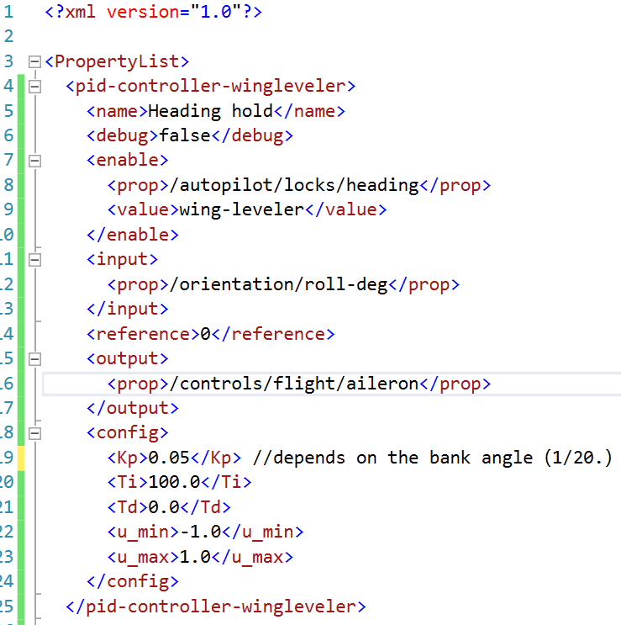

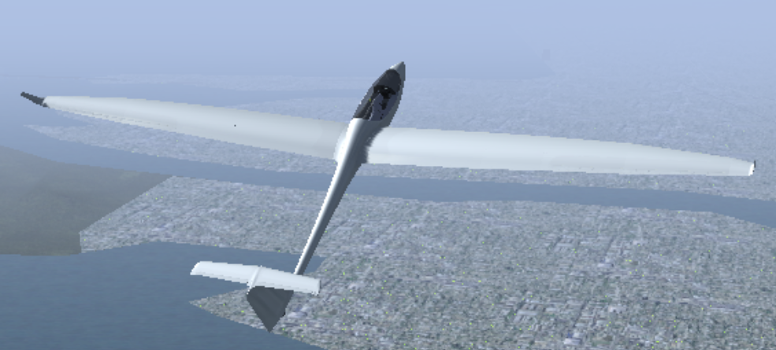

lateral hold mode,

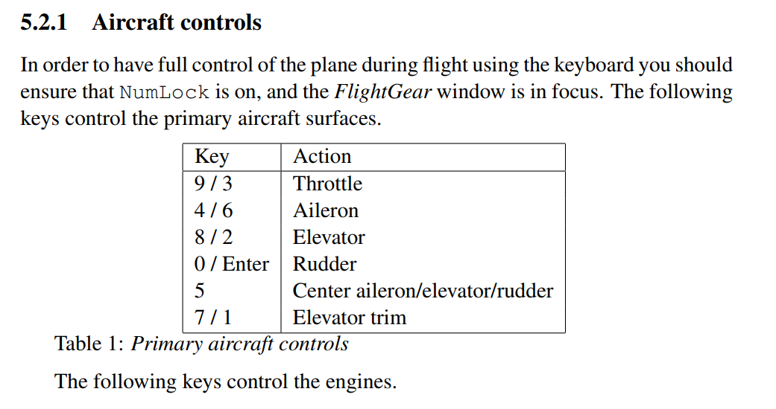

XFLR5

ASW28 DATABESE

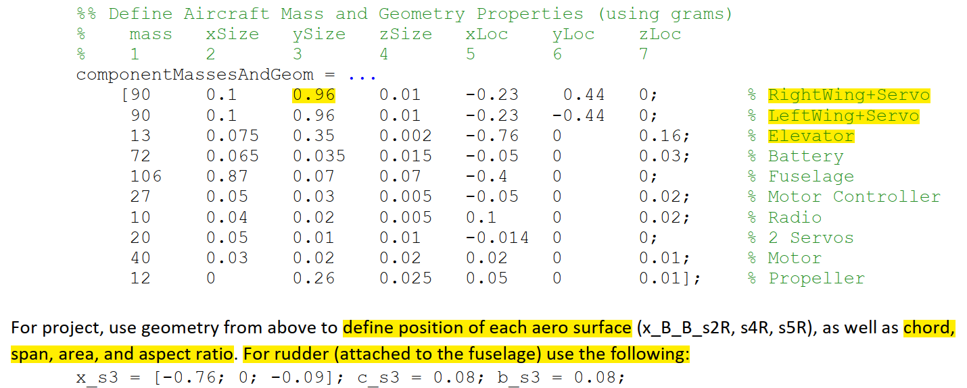

XLFR5 PARAMETERS:

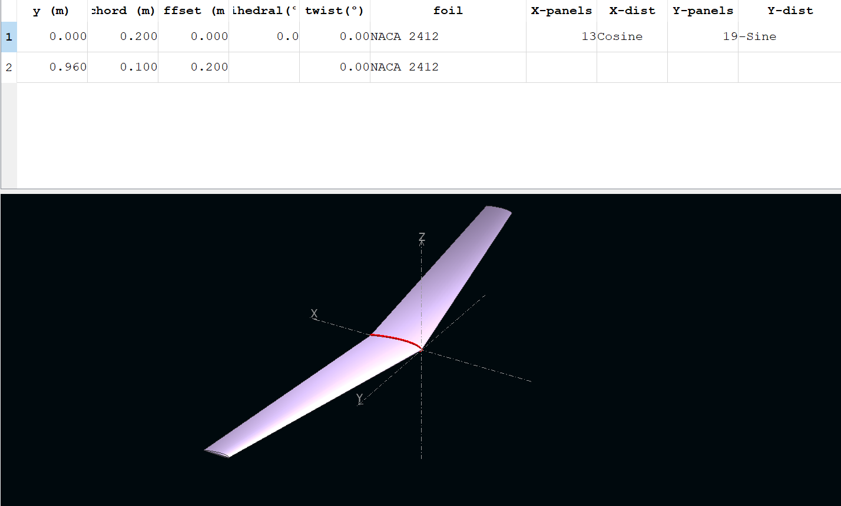

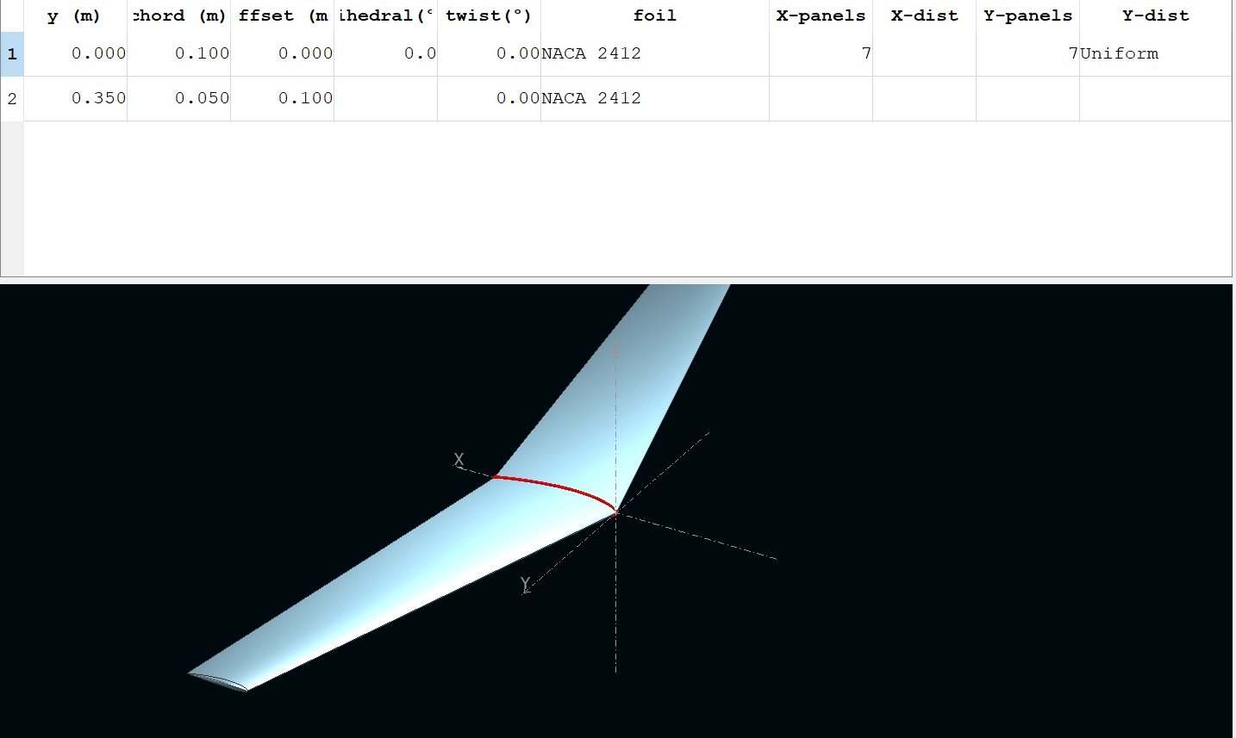

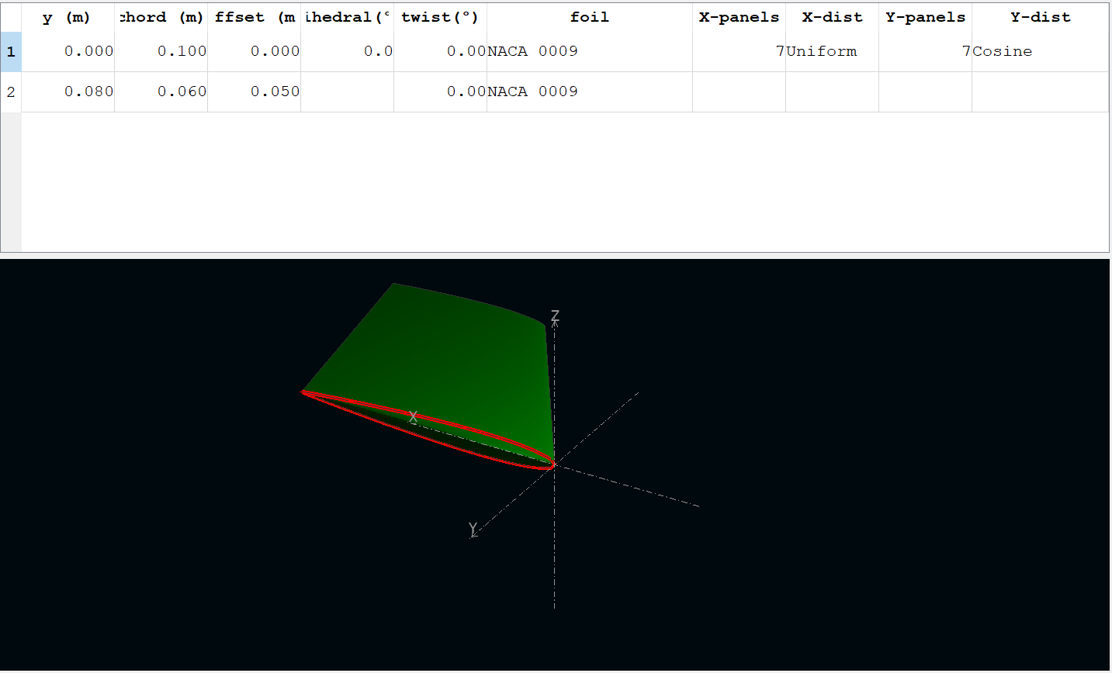

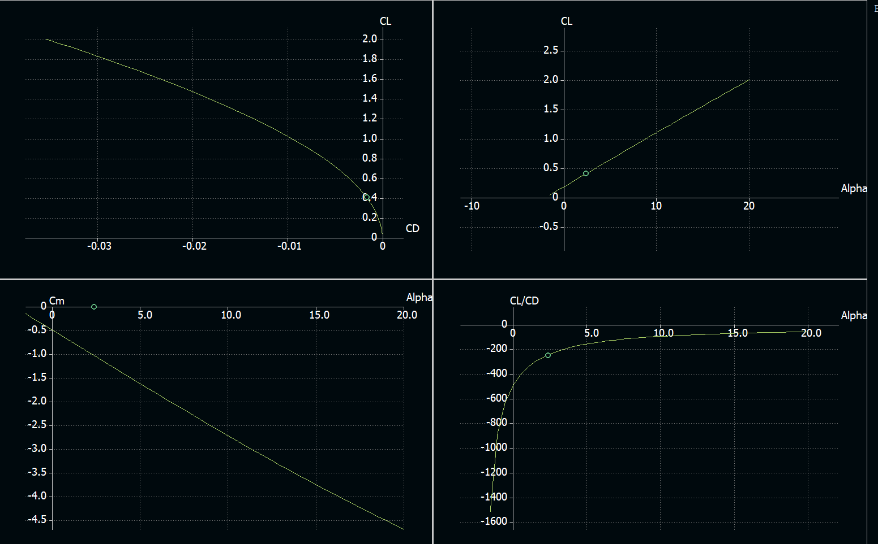Stability Analysis:

SolidWorks

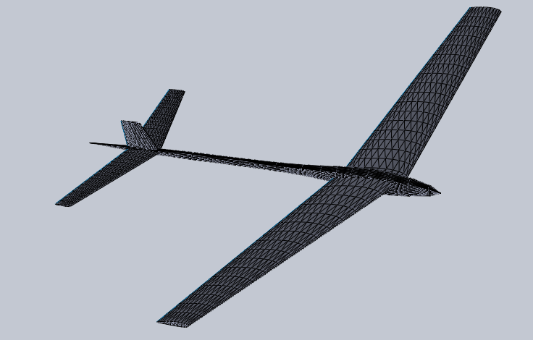

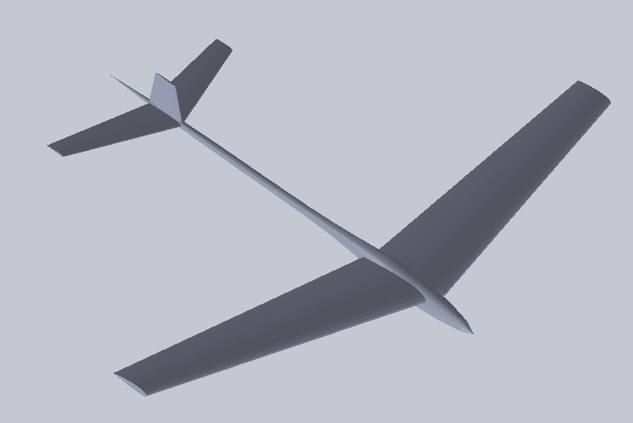

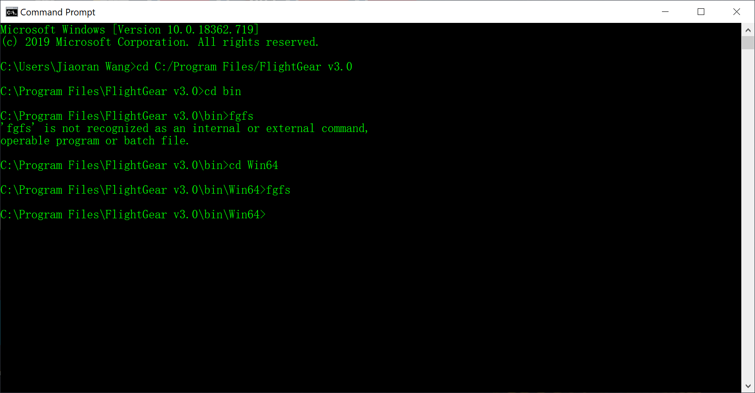

Solidworks(.VRML)—AC3D(.ac)

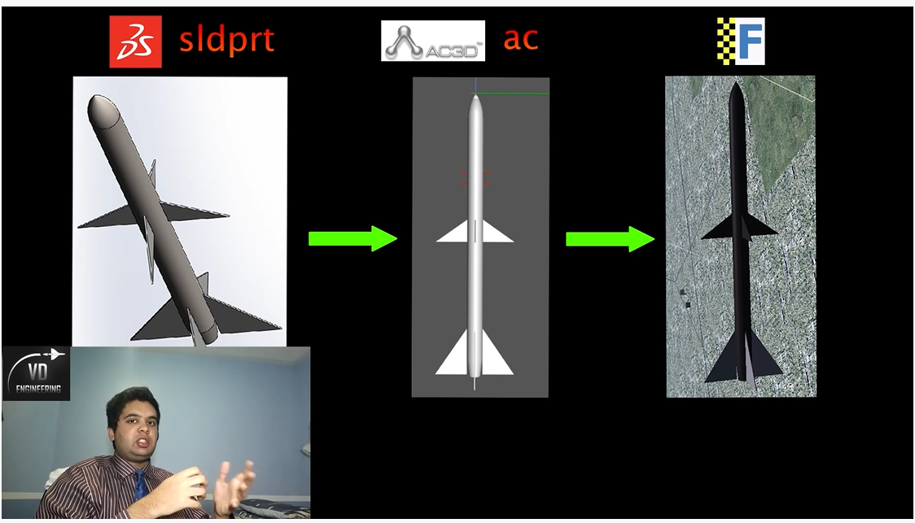

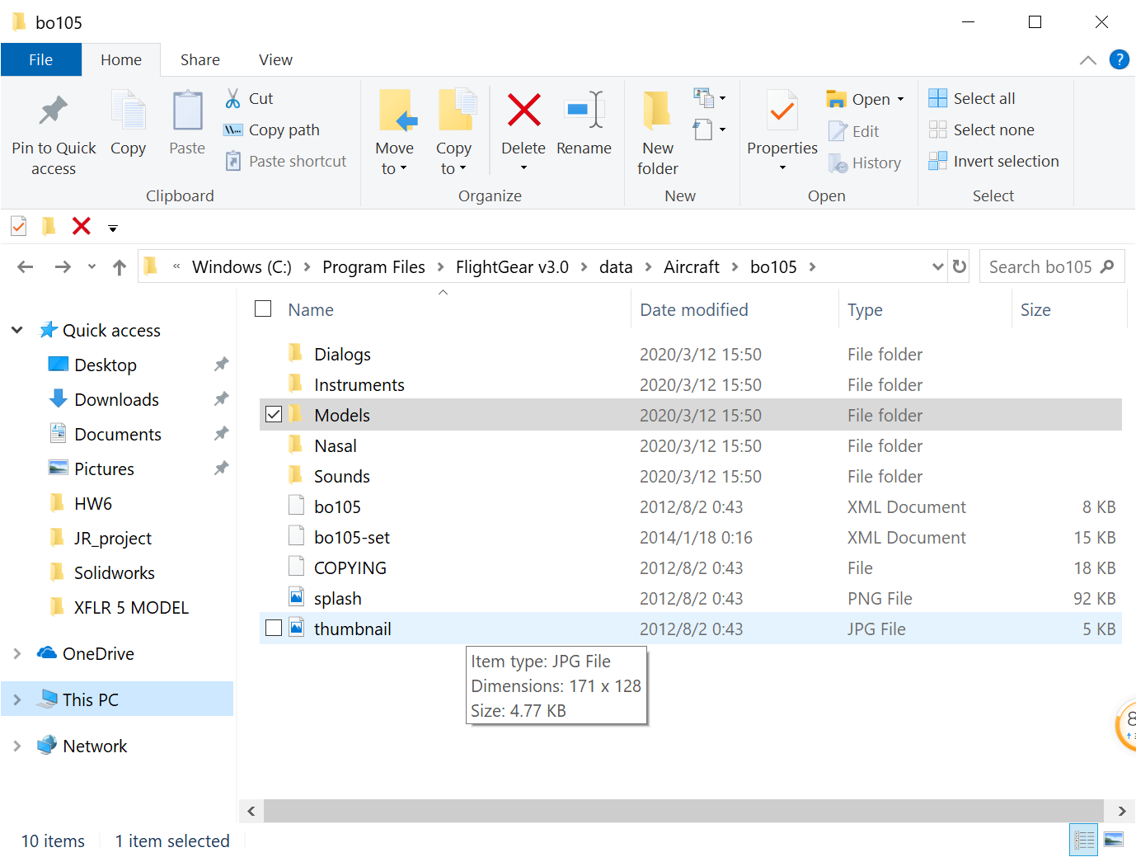

In AC3D

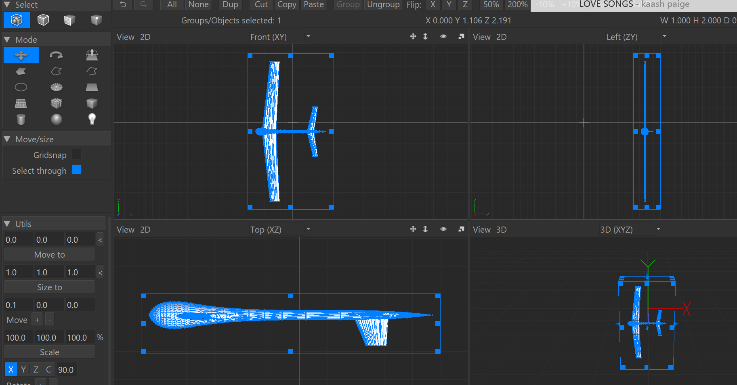

ANSYS for CFD Analysis

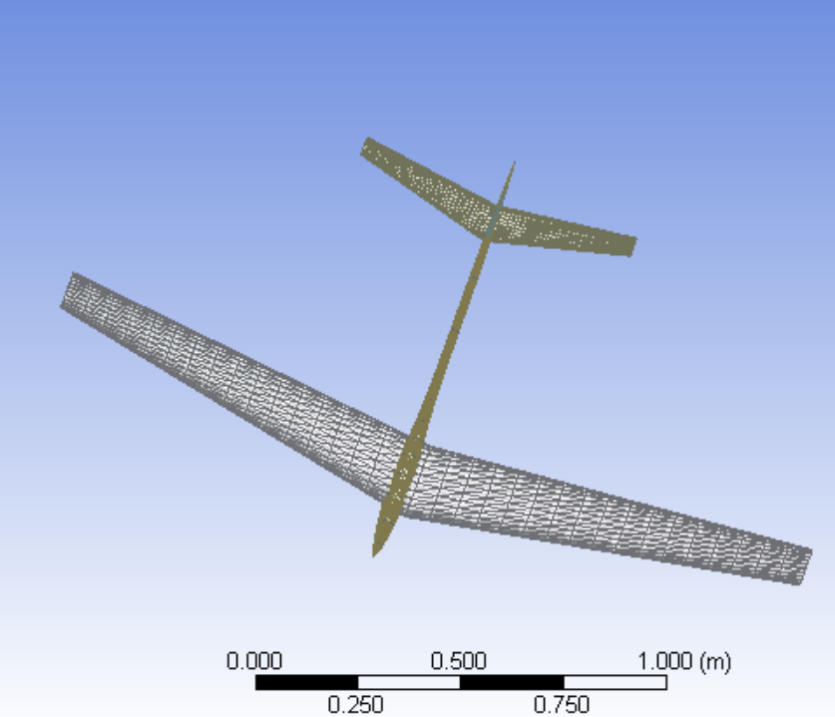

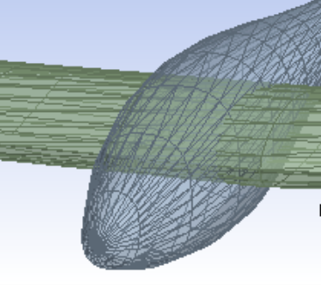

Attension:

1) units

2) better use .IGS/.STP instead of .STL to import models into DM

3) smaller size models help a lot while meshing(try 1/4)

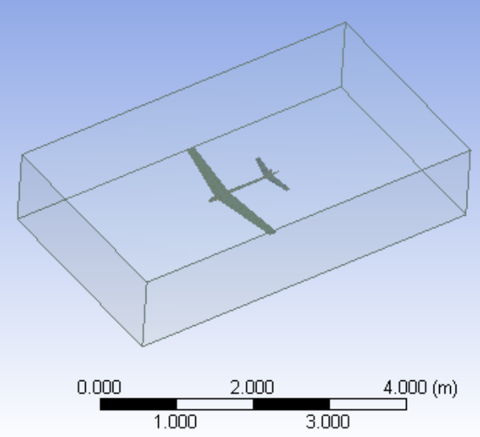

ICEM CFD

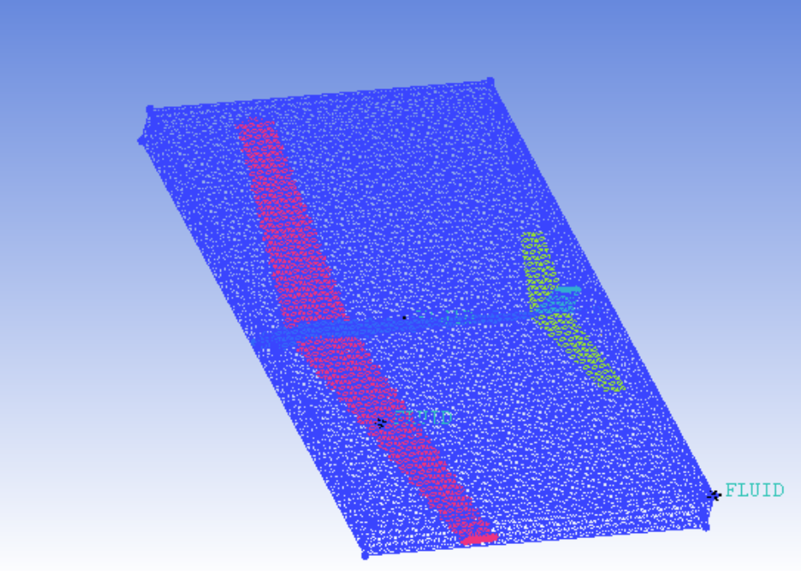

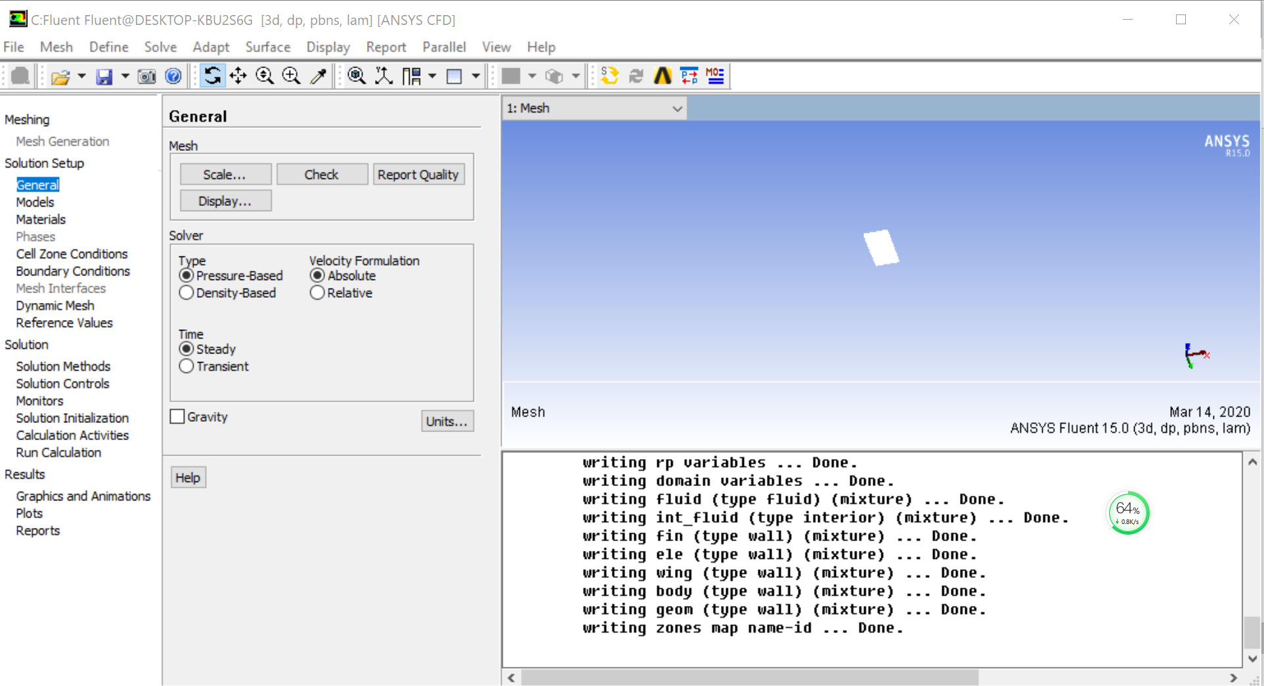

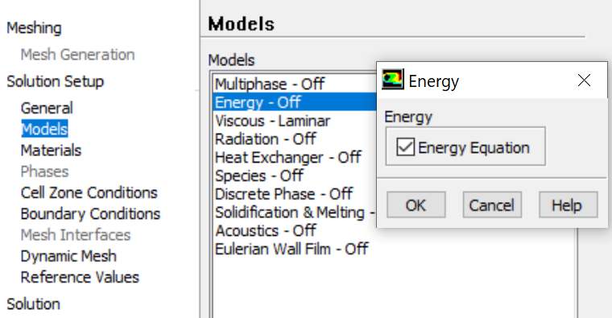

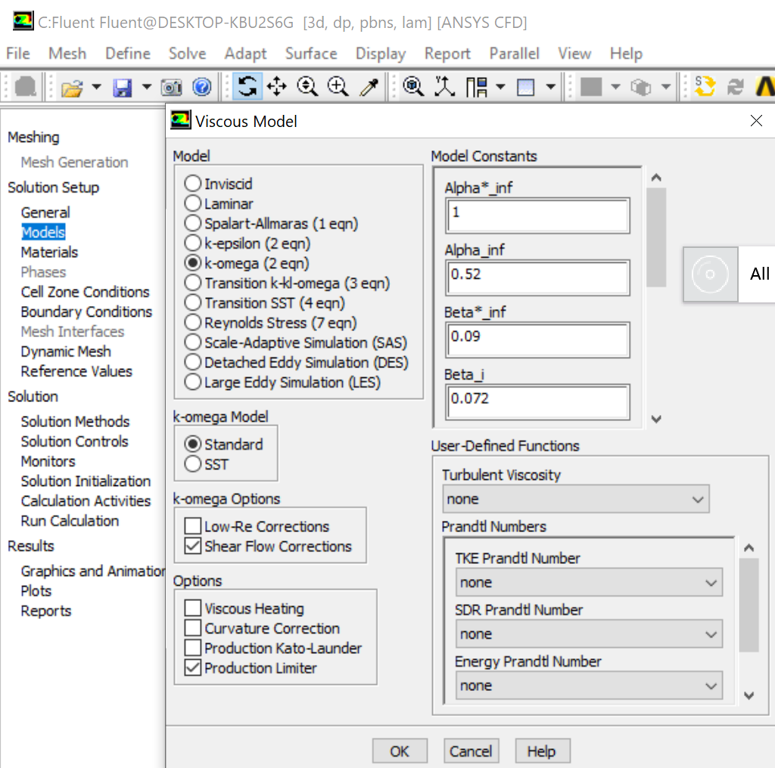

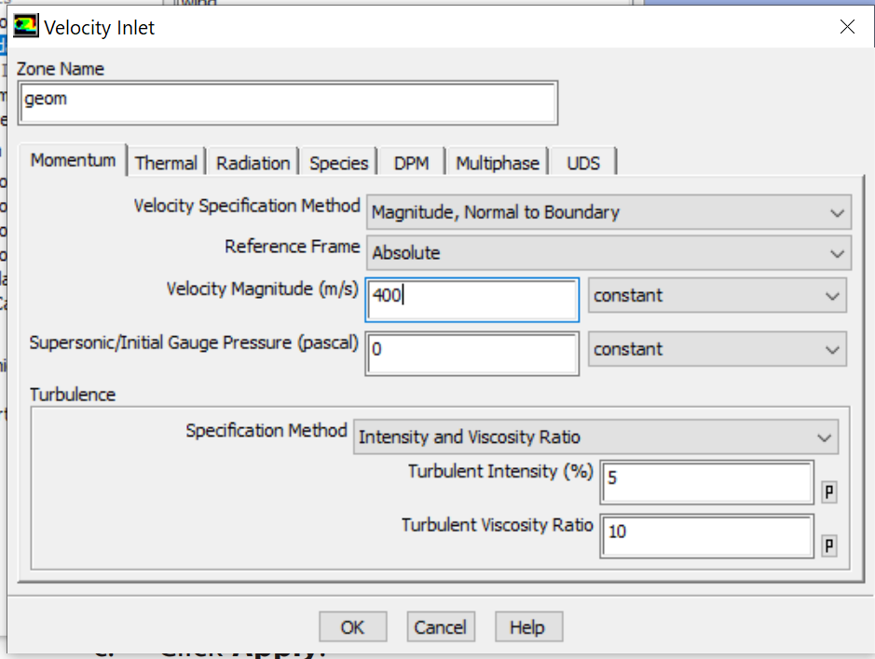

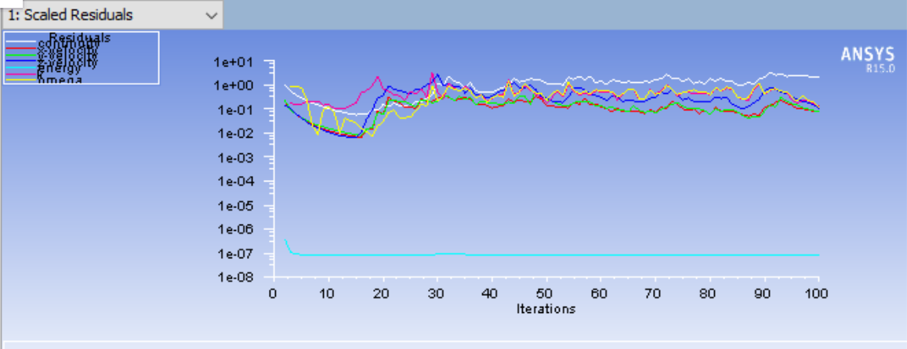

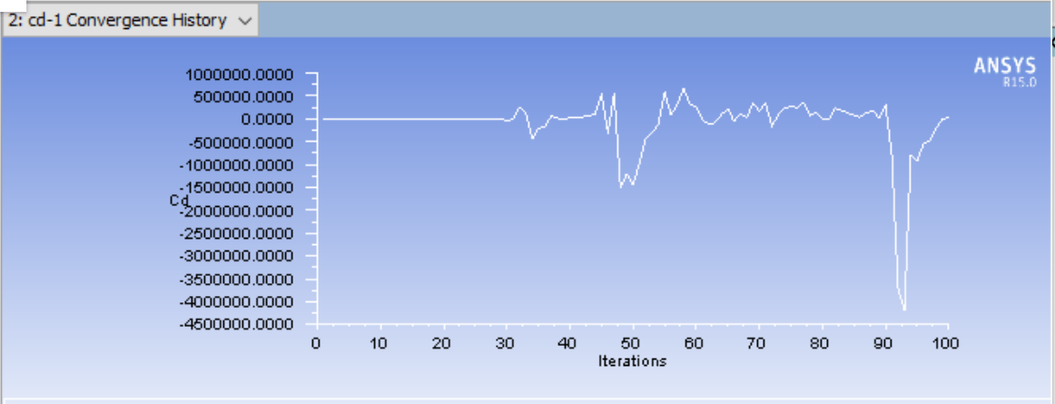

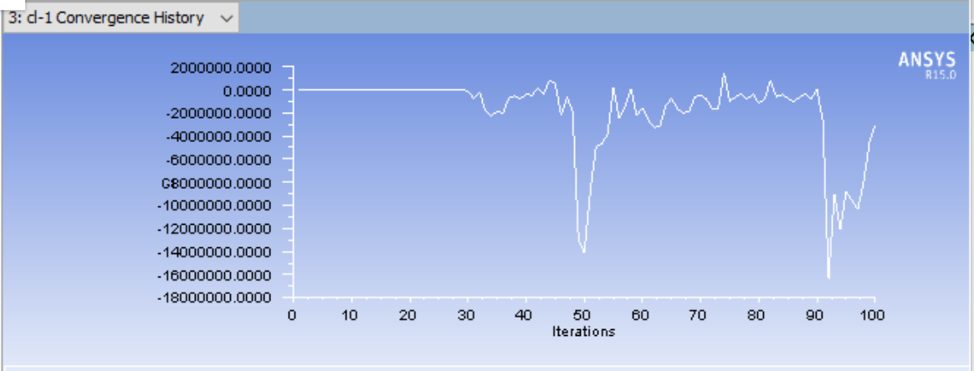

Post:

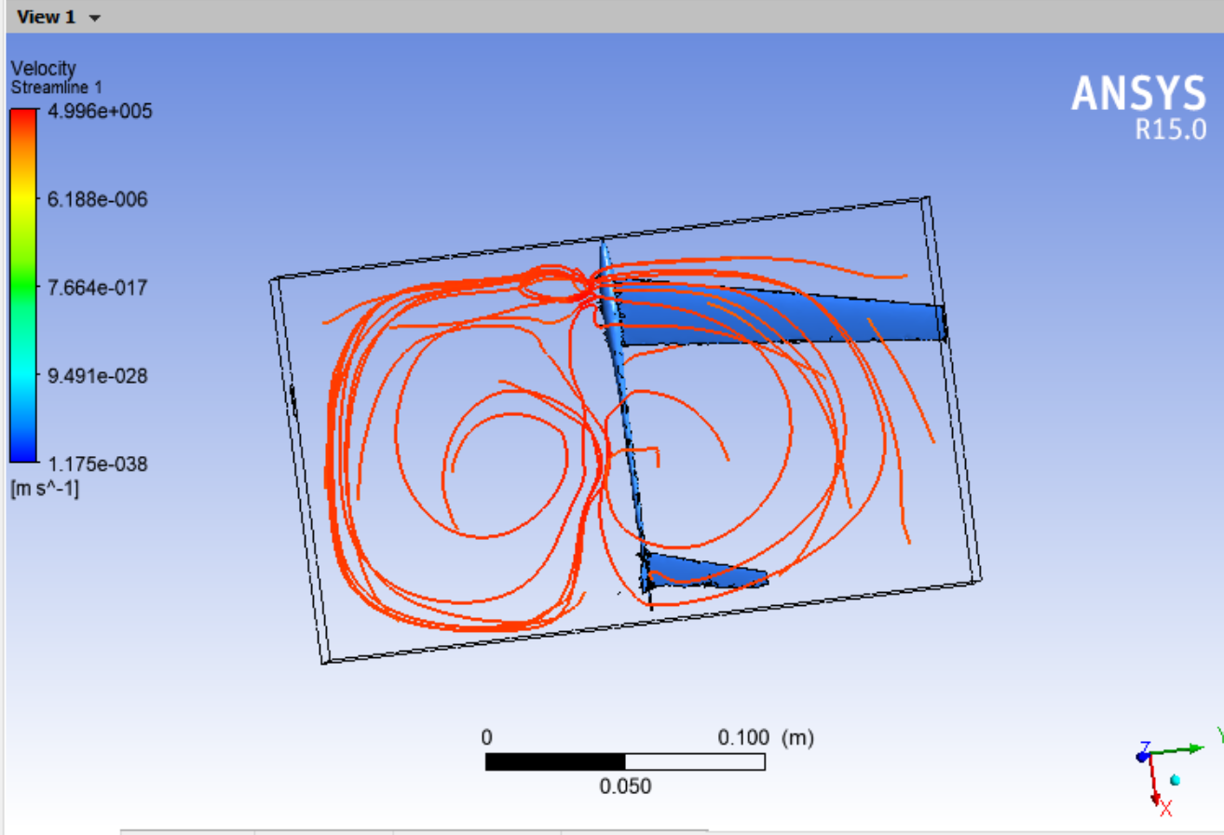

The problem could be the stl file is not smooth which affact the mesh quality:

Rebuild model in Solidworks

Regenerate:

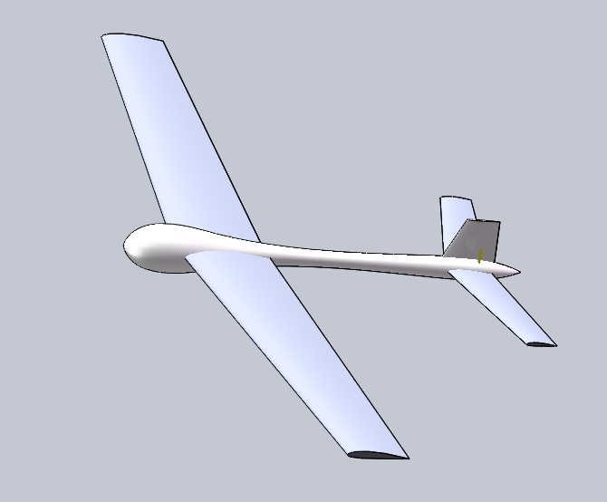

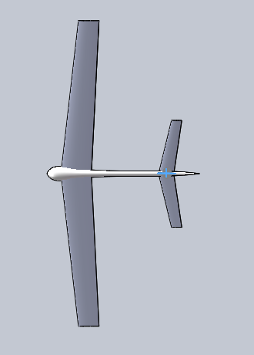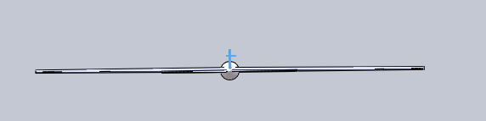

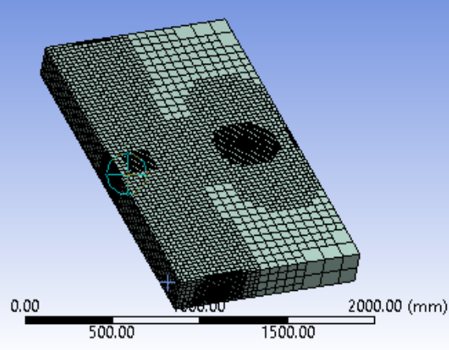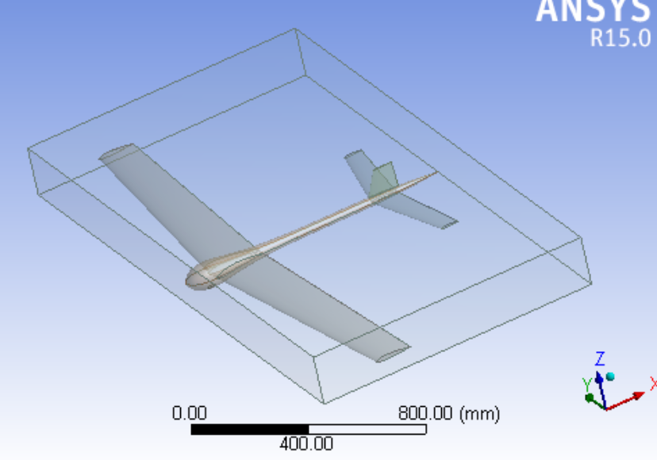

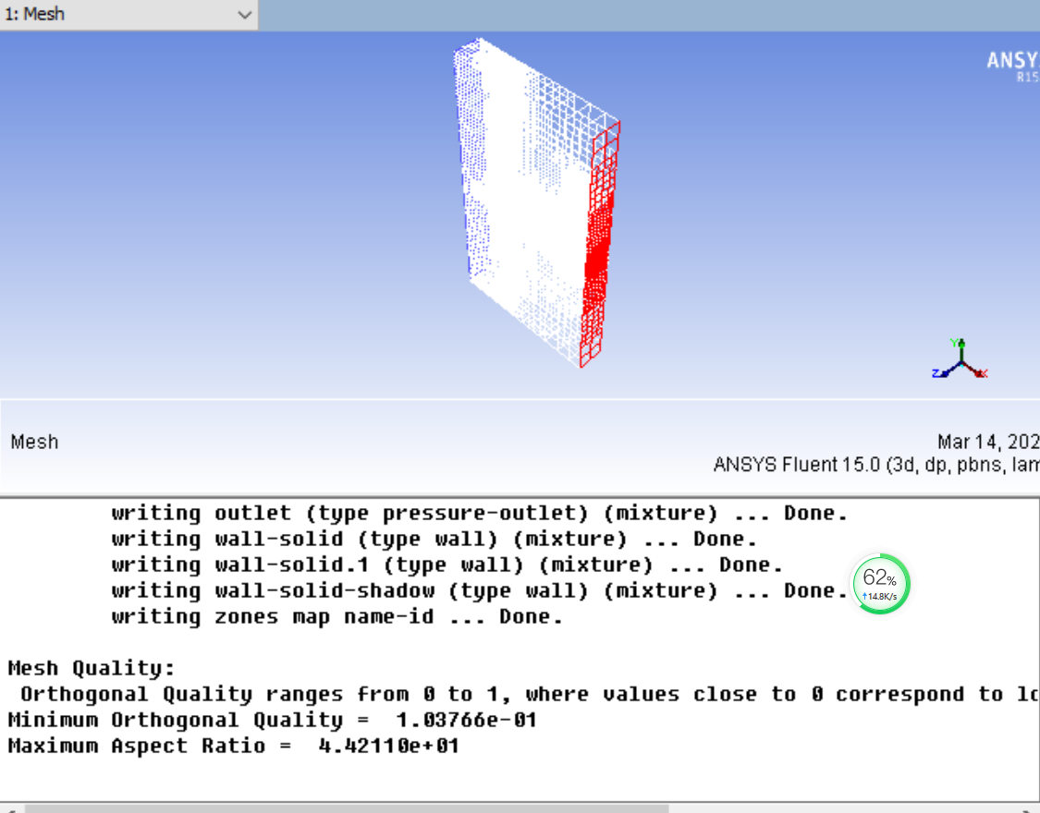

V=400

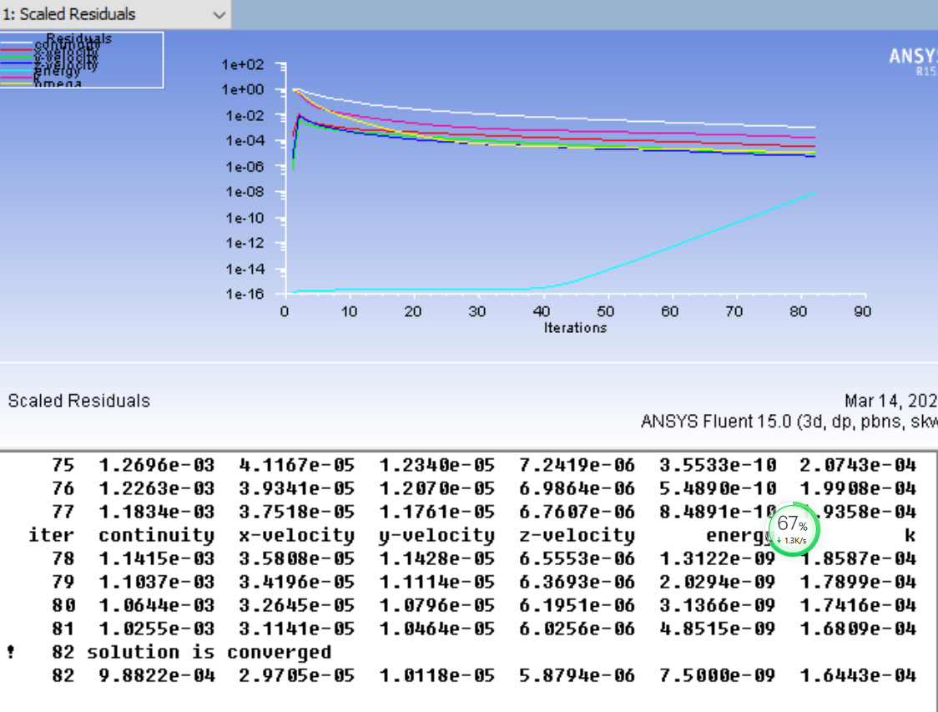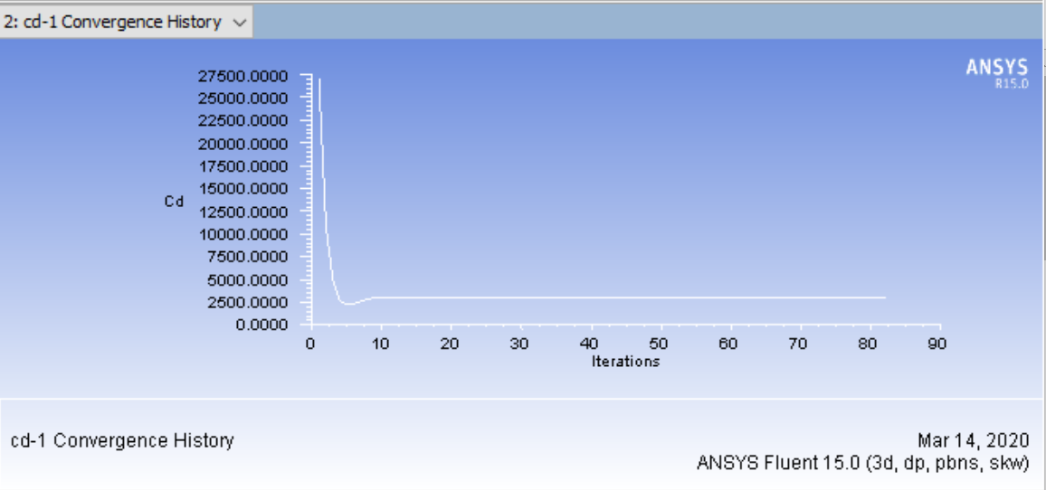

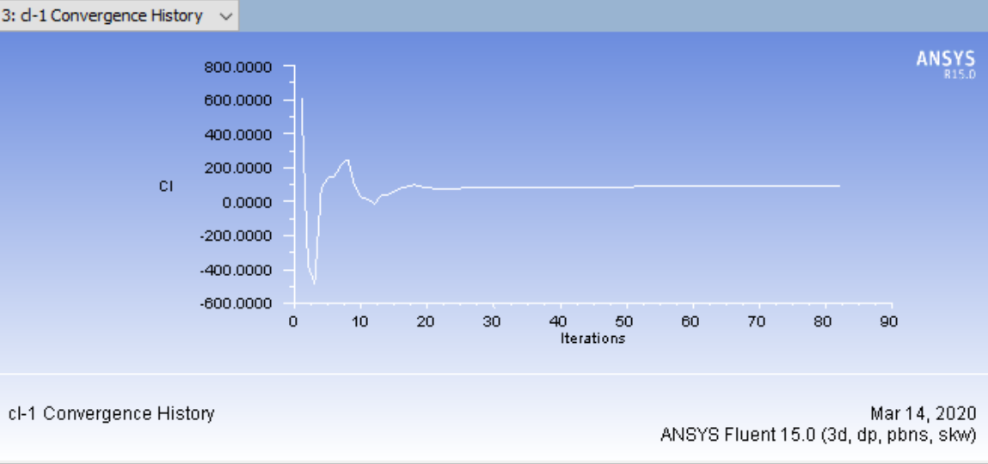

V=600

We could see after several steps of simulation the

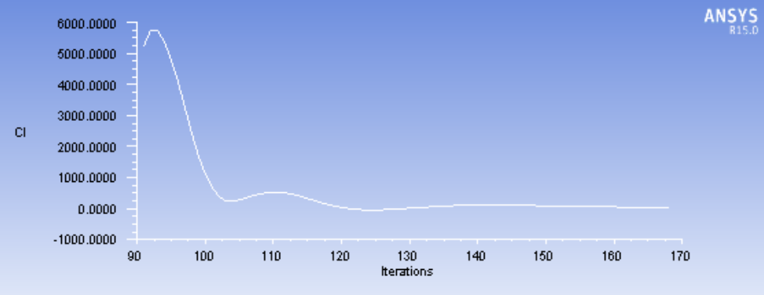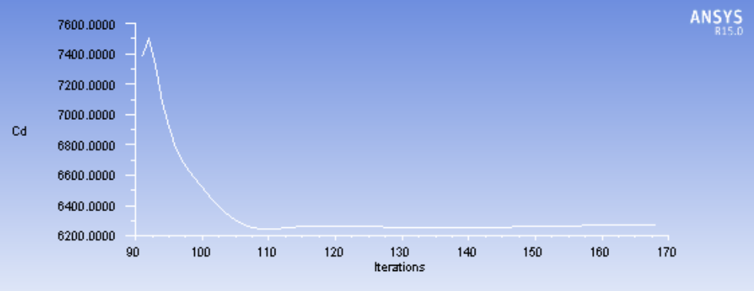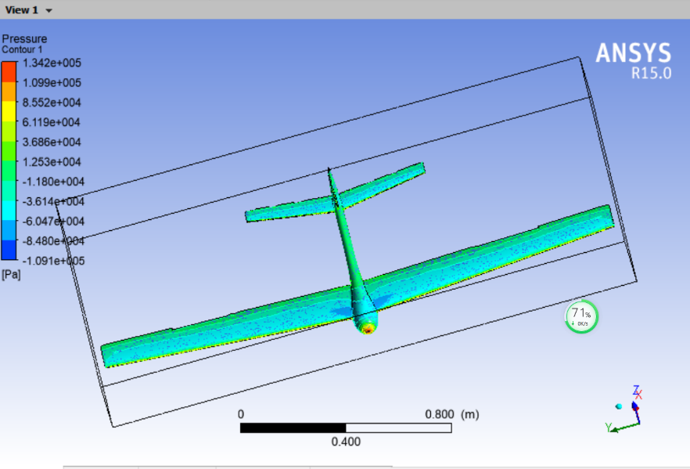

Post:

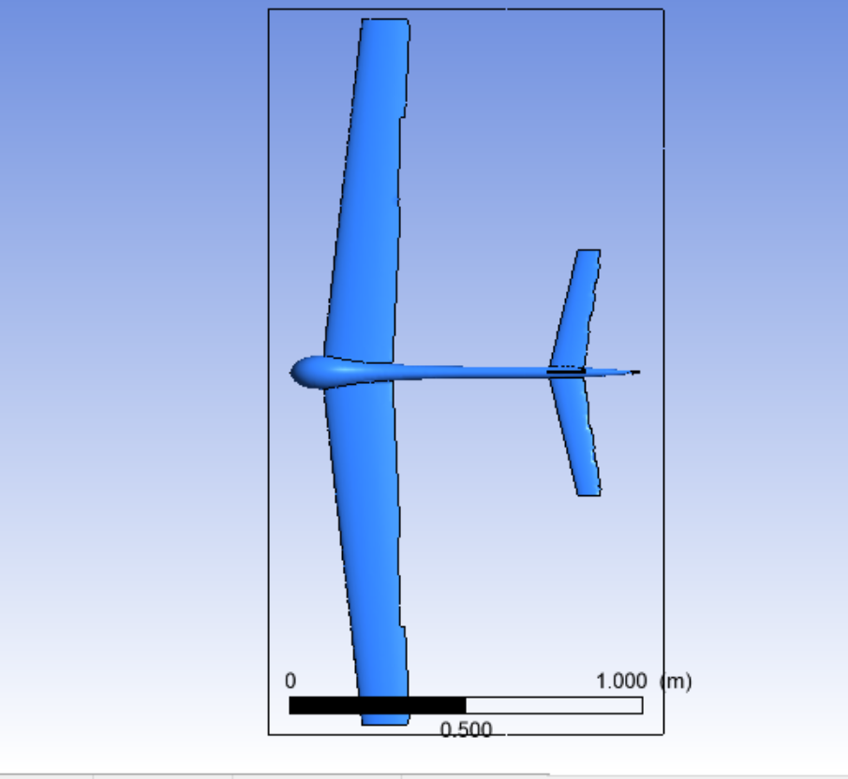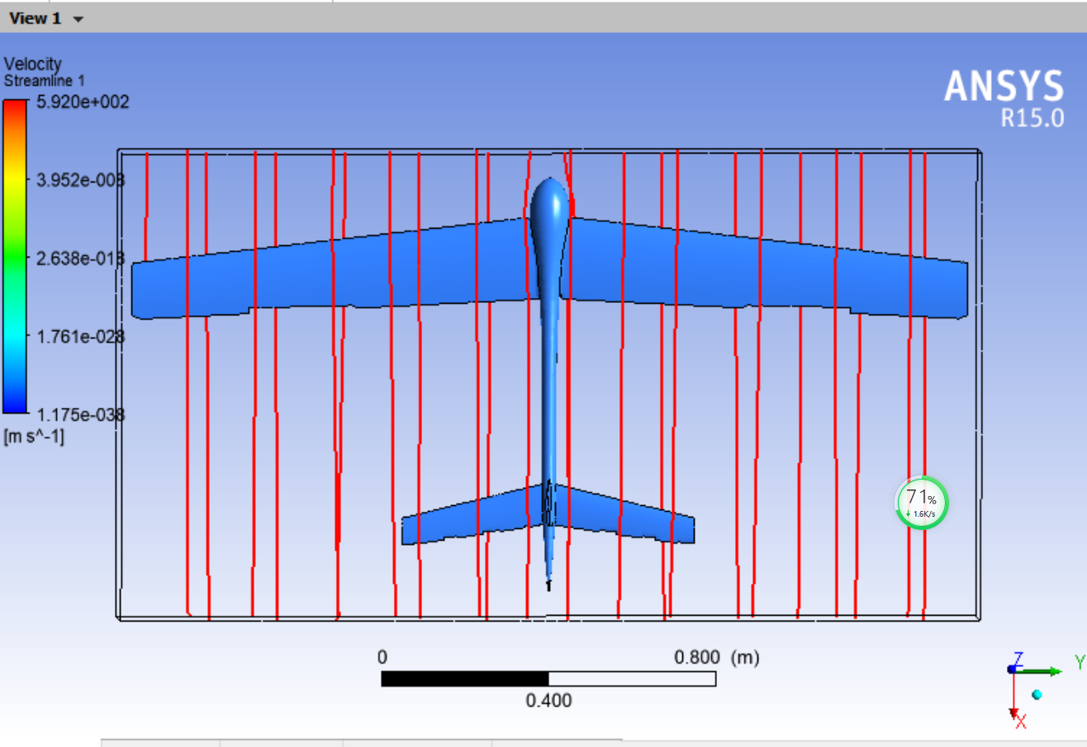

[1].STEVENS, B.L., F.L. LEWIS and E.N. JOHNSON, [1] Aircraft Control and Simulation Third Edition Dynamics, Controls Design, and Autonomous Systems, United States of America: John Wiley & Sons, Inc., Hoboken, New Jersey

[2]. Dr. Nelson, R.C., [2] Flight Stability and Automatic Control 2nd Ed.

[3]. Kaloust, J., C. Ham and Z. Qu, [3] Nonlinear autopilot control design for a 2-DOF helicopter model.

[4]. Chen, C., [4] System Theory and Design. Second Edition ed: Oxford University Press.

[5]. Yechout, T.R., et al., [5] Introduction to aircraft flight mechanics: American Institute of Aeronautics and Astronautics, Inc.1801 Alexander Bell Drive, Reston, VA 20191-4344.

[6]. Michael Basler, M.S., et al., [6] The FlightGear Manual for FlightGear Version 3.6.0.

[7]. Chambers, J.R. and R.M. Hall, [7] Historical Review of Uncommanded Lateral-Directional Motions at Transonic Conditions. JOURNAL OF AIRCRAFT, (Vol. 41, No. 3, May–June 2004).

[8]. Rauf, A., et al. [8] Aerodynamic modeling and state-space model extraction of a UAV using DATCOM and Simulink. 2011: IEEE.

[9]. Rysdyk, R., [9] Course and Heading Changes in significant wind. JOURNAL OF GUIDANCE, CONTROL, AND DYNAMICS, (Vol. 30, No. 4, July–August 2007).

[10]. Kubica, F. and T. Livet, [10] Flight Control Law Synthesis for A Flexible Aircraft. American Institute of Aeronautics, 1994.

References

Zv

**References:**

[1]. Dr. Nelson, R.C., [2] Flight Stability and Automatic Control 2nd Ed.

[2]. Kaloust, J., C. Ham and Z. Qu, [3] Nonlinear autopilot control design for a 2-DOF helicopter model.

[3]. Chen, C., [4] System Theory and Design. Second Edition ed: Oxford University Press.

[4]. Yechout, T.R., et al., [5] Introduction to aircraft flight mechanics: American Institute of Aeronautics and Astronautics, Inc.

1801 Alexander Bell Drive, Reston, VA 20191-4344.

[5]. Michael Basler, M.S., et al., [6] The FlightGear Manual for FlightGear Version 3.6.0.

[6]. Chambers, J.R. and R.M. Hall, [7] Historical Review of Uncommanded Lateral-Directional Motions at Transonic Conditions. JOURNAL OF AIRCRAFT, (Vol. 41, No. 3, May–June 2004).

[7]. Rauf, A., et al. [8] Aerodynamic modeling and state-space model extraction of a UAV using DATCOM and Simulink. 2011: IEEE.

[8]. Rysdyk, R., [9] Course and Heading Changes in significant wind. JOURNAL OF GUIDANCE, CONTROL, AND DYNAMICS, (Vol. 30, No. 4, July–August 2007).

[9]. Kubica, F. and T. Livet, [10] Flight Control Law Synthesis for A Flexible Aircraft. American Institute of Aeronautics, 1994.

**References:**

[1]. STEVENS, B.L., F.L. LEWIS and E.N. JOHNSON, [1] Aircraft Control and Simulation Third Edition Dynamics, Controls Design, and

Autonomous Systems, United States of America: John Wiley & Sons, Inc., Hoboken, New Jersey.

[2]. Dr. Nelson, R.C., [2] Flight Stability and Automatic Control 2nd Ed.

[3]. Kaloust, J., C. Ham and Z. Qu, [3] Nonlinear autopilot control design for a 2-DOF helicopter model.

[4]. Chen, C., [4] System Theory and Design. Second Edition ed: Oxford University Press.

[5]. Yechout, T.R., et al., [5] Introduction to aircraft flight mechanics: American Institute of Aeronautics and Astronautics, Inc.

1801 Alexander Bell Drive, Reston, VA 20191-4344.

[6]. Michael Basler, M.S., et al., [6] The FlightGear Manual for FlightGear Version 3.6.0.

[7]. Chambers, J.R. and R.M. Hall, [7] Historical Review of Uncommanded Lateral-Directional Motions at Transonic Conditions. JOURNAL OF AIRCRAFT, (Vol. 41, No. 3, May–June 2004).

[8]. Rauf, A., et al. [8] Aerodynamic modeling and state-space model extraction of a UAV using DATCOM and Simulink. 2011: IEEE.

[9]. Rysdyk, R., [9] Course and Heading Changes in significant wind. JOURNAL OF GUIDANCE, CONTROL, AND DYNAMICS, (Vol. 30, No. 4, July–August 2007).

[10]. Kubica, F. and T. Livet, [10] Flight Control Law Synthesis for A Flexible Aircraft. American Institute of Aeronautics, 1994.

A. Rauf, Muhammad Aamir Zafar, Z. Ashraf and H. Akhtar, "Aerodynamic modeling and state-space model extraction of a UAV using DATCOM and Simulink," 2011 3rd International Conference on Computer Research and Development, Shanghai, 2011, pp. 88-92.

Useful links

How to dynamically change a block parameter value during simulation run-time?

<https://www.mathworks.com/matlabcentral/answers/334224-how-to-dynamically-change-a-block-parameter-value-during-simulation-run-time>

<https://www.mathworks.com/help/releases/R2017a/simulink/ug/using-tunable-parameters.html>

<https://uk.mathworks.com/help/simulink/ug/tune-and-visualize-your-model-with-dashboard-blocks.html>

Send fdm to flightgear

<https://www.mathworks.com/help/aeroblks/sendnet_fdmpackettoflightgear.html>

<https://www.mathworks.com/help/aeroblks/sendnet_fdmpackettoflightgear.html>

<https://www.mathworks.com/help/aeroblks/packnet_fdmpacketforflightgear.html>

<https://www.youtube.com/watch?v=jB-80cvV1Ao>

<https://forum.flightgear.org/viewtopic.php?f=36&t=32707>

<https://www.mathworks.com/help/aeroblks/packnet_fdmpacketforflightgear.html>

S function/UDP

<https://www.mathworks.com/help/simulink/sfg/sim-viewing-devices-in-external-mode.html>

<https://www.mathworks.com/help/simulink/sfg/example-of-a-basic-c-mex-s-function.html#f8-82449>

<https://www.mathworks.com/help/aeroblks/packnet_fdmpacketforflightgear.html>

<https://www.mathworks.com/matlabcentral/answers/309926-matlab-udp-recieve-error>

Simulink Animation

<https://www.mathworks.com/videos/modeling-simulation-and-flight-control-design-of-an-aircraft-with-simulink-81546.html>

<https://www.mathworks.com/products/aerospace-toolbox.html>

ANSYS FLUENT

<https://www.youtube.com/watch?v=2x1Qx15pzm0>

<https://www.youtube.com/watch?v=HGzcVkDPHe4>

<https://www.youtube.com/watch?v=kuEqlSmyAos>

MODEL ASW28 to FG

<https://www.youtube.com/watch?v=Wb9bzS80ThA>

<http://wiki.flightgear.org/Blender_AC3D_import_and_export>

SOLIDWORKS

<https://www.youtube.com/watch?v=2iE_zo16bWM>

<https://www.youtube.com/watch?v=c_QEEPGUxDg>

<https://www.youtube.com/watch?v=aT9z-D_dwU4>

Controller design

<https://www.mathworks.com/videos/pid-control-made-easy-81646.html>

<https://www.mathworks.com/videos/trim-linearization-and-control-design-for-an-aircraft-68880.html>

<https://www.youtube.com/watch?v=LzQPJRt00Ng>

<https://www.mathworks.com/videos/automatic-tuning-of-a-helicopter-flight-control-system-90590.html>

<https://www.mathworks.com/videos/linear-system-analysis-in-simulink-81587.html>

<https://www.youtube.com/watch?v=CJGlKCfGEA0>

AutoPilot Design

<http://wiki.flightgear.org/Howto:Design_an_autopilot>

Linmod()

<https://www.mathworks.com/help/slcontrol/ug/linearize-at-trimmed-operating-point.html>

<https://www.mathworks.com/help/slcontrol/ug/linearize-simulink-model.html>

<https://www.mathworks.com/help/slcontrol/ug/specify-model-portion-to-linearize.html>

<https://www.mathworks.com/help/slcontrol/ug/linearize-at-simulation-snapshot.html>

<https://www.mathworks.com/videos/linear-system-analysis-in-simulink-81587.html>